MegaProektStroy LLC
Russia, 394006, Voronezh, 20th Anniversary of October Str., Bldg 103, of. 424a
OGRN 1123668038273, TIN 3664120580
Certificate SRO-P-168-22112011 of Permit to Certain Type or Types of Work Affecting Safety of Capital Construction Projects

Mobile Data Processing Center

DETAILED DESIGN DOCUMENTATION

Main Set of Design Drawings

MDPC-12/17

Voronezh, 2017

Contents of Sections of the Detailed Design Documentation on the Mobile Data Processing Center
Item No. | Designation | Description of | Remark
 |  | Power Supply System
1 | MDPC-12/17-EL | Indoor Electrical Equipment & Lighting
 |  | Fire Suppression System
2 | MDPC-12/17-PT | Fire Suppression

List of Main Set Detailed Drawings

Sheet | Description | Remark
1-2 | General Information
3 | Functional Diagram
4 | Equipotential Bonding System
5 | LID P1 Electrical Schematic Diagram (Input #1, 2) | 8 sheets
6 | LID P2 Electrical Schematic Diagram (Input #3, 4) | 8 sheets
7 | LID P3 Electrical Schematic Diagram (Input #5, 6) | 9 sheets
8 | DP Center. Elev. +0.000. Layout of Lighting Equipment &
 | Grounding
9 | DP Center. Elev. +0.000. Electrical Power Equipment Layout
10 | DP Center. Elev. +0.000. Layout of Equipment and Cable Lines
11 | View А-А, B-B
12 | DP Center. Elev. +0.000. Tray Layout and Mounting Plan
13 | LID Cable List (Input #1) | 7 sheets
14 | LID Cable List (Input #2) | 7 sheets
15 | LID Cable List (Input #3) | 7 sheets
16 | LID Cable List (Input #4) | 7 sheets
17 | LID Cable List (Input #5) | 7 sheets
18 | LID Cable List (Input #6) | 7 sheets

List of Reference and Attached Documents

Designation | Description | Remark
 | Attachments
MDPC-12/17-EL.SO | Equipment, Goods and Materials Specification | 2 sheets
MDPC-12/17-EL.PZ | Explanatory Note | 9 sheets
Legend

Designation | Description | Remark
 | LID Cabinet
 | Wireless Hygrostat
 | Single-Pole Socket Outlet with Protective Contact
 | Single-Pole Flush Switch
 | LED Ceiling/Wall Luminaire
 | Cables Laid Open in Cable Trays
 | Ground Line
 | Equipment Group Supplied from LID (Input #1)
 | Equipment Group Supplied from LID (Input #2)
 | Equipment Group Supplied from LID (Input #3)
 | Equipment Group Supplied from LID (Input #4)
 | Equipment Group Supplied from LID (Input #5)
 | Equipment Group Supplied from LID (Input #6)

General
- The detailed design is based on:
- GOST 21.210-2014. Graphic Symbols of Electrical Equipment and Wiring on Plans.
- (EIC, 7th edition). Electrical Installations Code.
- GOST 21.613-2014. System of Design Documents for Construction. Power Electrical Equipment. Detailed Drawings.
- GOST 31565-2012. Cable Products. Requirements of Fire Safety.
- SP 31-110-2003. Design and Erection of Electrical Equipment in Residential and Public Buildings.
- GOST R 50571.5.52-2011. Low-Voltage Electrical Installations. Part 5-52. Selection and Installation of Electrical Equipment. Wiring Systems.
- GOST R 50571.5.54-2013. Low-Voltage Electrical Installations. Part 5-54. Selection and Erection of Electrical Equipment. Earthing Arrangements, Protective Conductors and Protective Bonding Conductors.
- The detailed design documentation is allowed for the performance of works after it has been checked and agreed with the Customer.
- The detailed design drawings have been developed in accordance with the current norms, rules and standards on the basis of the terms of reference, the basis of design provided by the Customer, as well as the specifications.
- The facility falls under category III of electric reliability.
- The mains voltage is 230/400 V.
- The grounding system is TN-C-S.
- The detailed design resolves the internal power supply of the Mobile Data Processing Center.
The equipment is supplied from the ABB lead-in distributors equipped with six inputs. The electric power metering is provided by the transformer operated meters installed in the lead-in distributor cabinets.
- The lighting control is provided by individual switches installed at the entrances to the premises. The type and number of luminaires in the premises are taken in accordance with the standardized lighting performance specified in SP 52.13330.2011 "Daylighting and Artificial Lighting", SP 31-110-2003 "Design and Erection of Electrical Equipment in Residential and Public Buildings" subject to safety, durability and reliability of lighting performance in the given environment.
- The Li YY(А)-LS cable is used for power distribution and group networks and is laid open in cable trays and HDPE pipes.
- For server equipment power supply lines, the Li YY(A)-LS 3x1.5 cable should be used according to the customer's special request.
- The lead-in cables to be covered with fire-resistant paint in accordance with SP 6.13130.2009, p. 4.1, EIC (7th ed.).
- The building entrance facility shall have an equipotential bonding system. For this purpose, the structural steelwork and the metal sheathing of the building, the protective conductors of the supply mains shall be connected to the main grounding bus within the lead-in distributor. According to EIC, p. 1.7.61, the detailed design provides for the main grounding bus double earthing at the building entrance facility.
- To ensure protection of maintenance personnel from electrocution, provision should be made for neutral earthing by connecting to the network zero protective conductor in accordance with EIC
of all normally non-conducting elements of electrical equipment, trays and other equipment that can become live in the event of damage to insulation.

Description |  | Qty
Electrical power supply category |  | lll
Mains voltage, | V | 380/220V
Power consumption, | kW | 1023.21
Max. loss of voltage, | % | 1.0

The engineering solutions adopted in the detailed design comply with the environmental, sanitary and hygiene, fire safety and other rules and regulations in force in the Russian Federation to ensure life and health friendly operation of the system subject to the planned activities.
Chief Project Engineer__________________

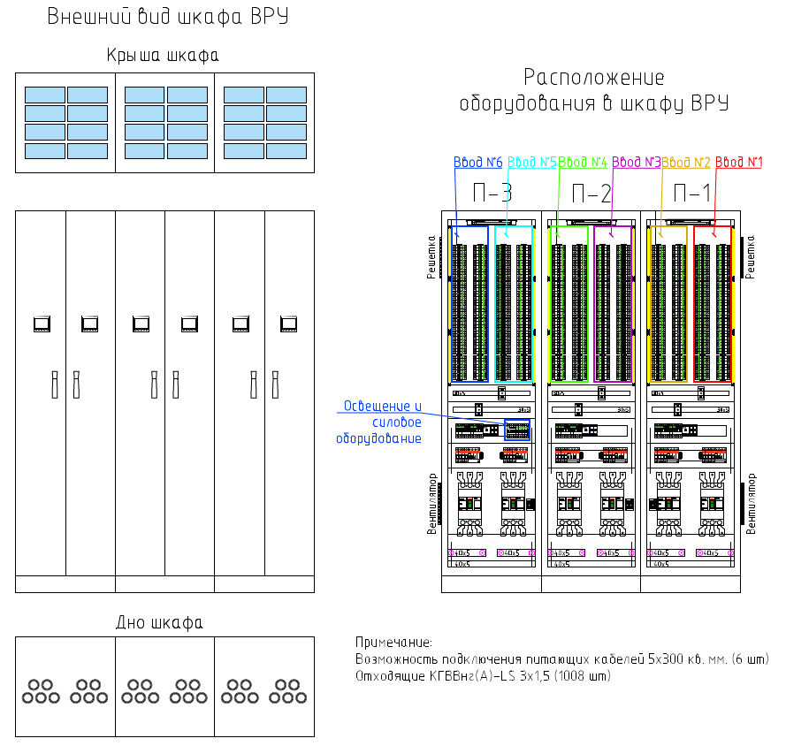
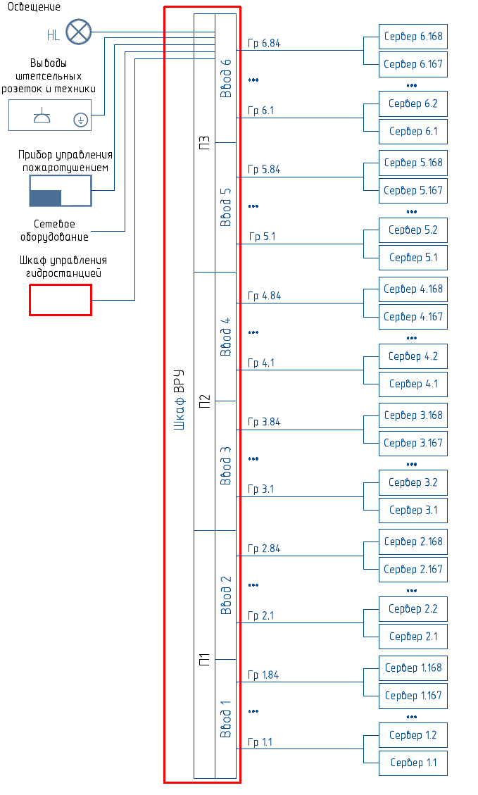
Functional Diagram
Lighting
LID Cabinet Outside View
Server
LID Cabinet Equipment Layout
Cabinet cover
Lattice
Input #1
Input #2
Input #3
Input #5
Input #4
Input #6
Lighting and power equipment
Server
Server
Server
Server
Server
Server
Server
Server
Server
Server
Server
Server
Server
Server
Server
Server
Server
Server
Server
Server
Server
Server
Server
Input 1
Input 2
Input 3
Input 4
Input 5
Input 6
LID Cabinet
Network equipment
Hydraulic control cabinet
Socket outlet and hardware outputs
Fire suppression controller
Fan
Note:
Connectivity of 5x300 sq.mm supply cables (6 pcs). Outgoing NYM-O (N)YM(St) (А)-LS 3x1.5 (1008 pcs) cables.
Cabinet bottom

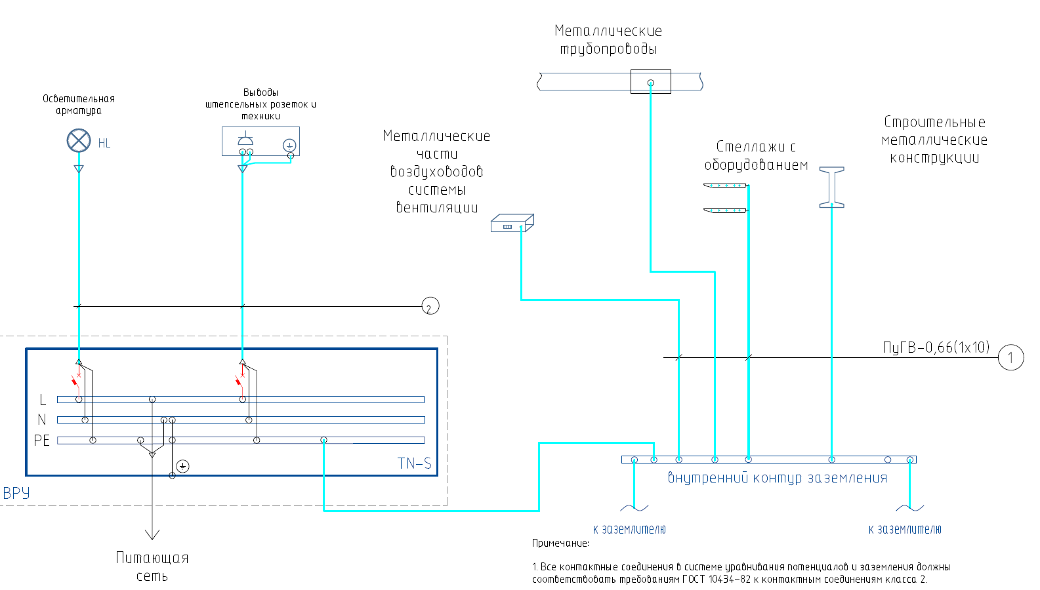
Note:
1. In the equipotential bonding & grounding system, all contact connections must comply with the requirements of GOST 10434-82 for Class 2 contact connections.
TO GROUNDING WIRE
TO GROUNDING WIRE
Inner grounding circuit
Supply mains
Structural steelwork
Racks with equipment
Metal parts of ventilation ducts
Metal conduits
Socket outlet and hardware outputs
Lighting fixtures

Legend:
- Main equipotential bonding conductor;
- Zero protective conductor (PE core of corresponding cables)
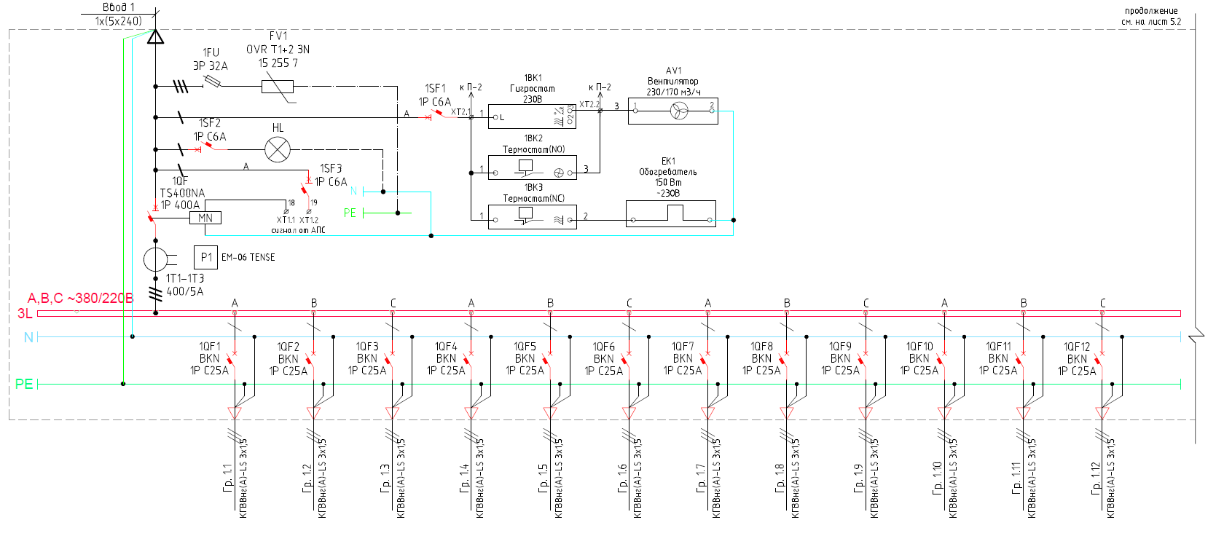
Contd.,
see Sheet 5.2
Input 1
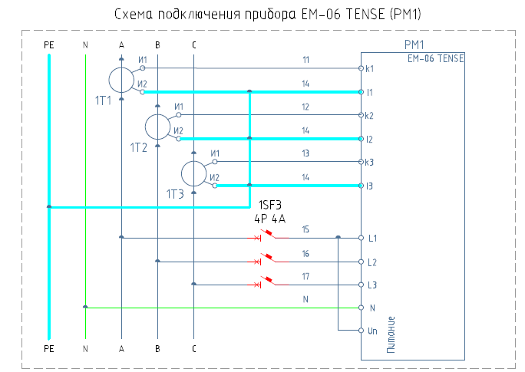
V
Gr.
Gr.
Gr.
Gr.
Gr.
Gr.
Gr.
Gr.
Gr.
Gr.
Gr.
Gr.
150W
~230V
W
Power supply
AFAS signal
to P-2
to P-2
AV1
Fan
230/170 m³/h
Thermostat (NO)
Thermostat (NC)
Heater
Hygrostat
ЕМ-06 TENSE (PM1) Connection Diagram

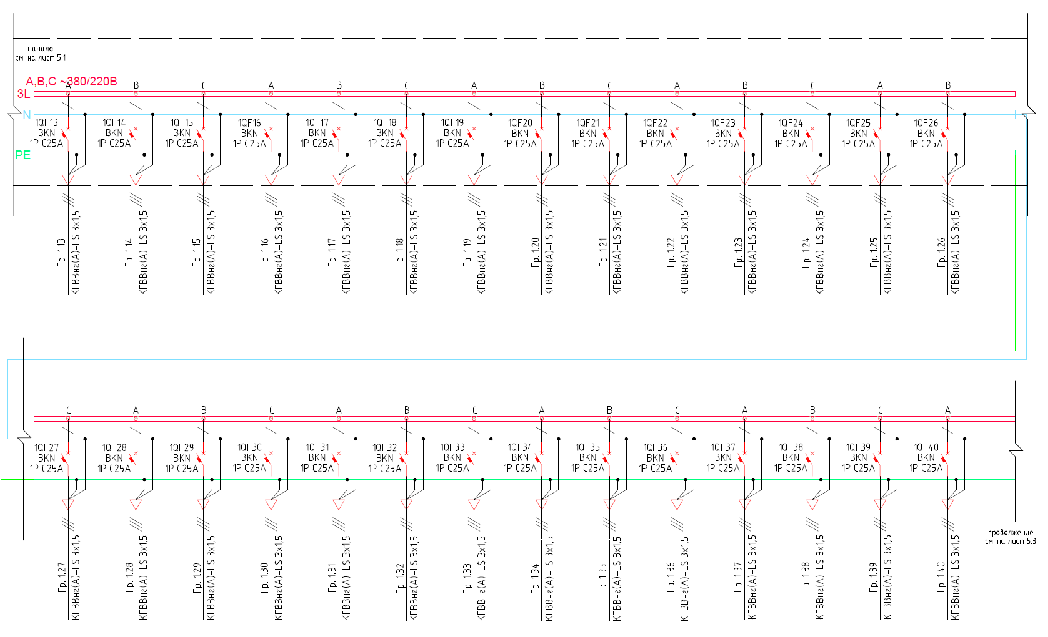
Contd.,
see Sheet 5.3
Gr.

Gr.

Gr.

Gr.

Gr.

Gr.

Gr.

Gr.

Gr.

Gr.

Gr.

Gr.

Gr.

Gr.

Gr.

Gr.

Gr.

Gr.

Gr.

Gr.

Gr.

Gr.

Gr.

Gr.

Gr.

V
Beginning,
see Sheet 5.1

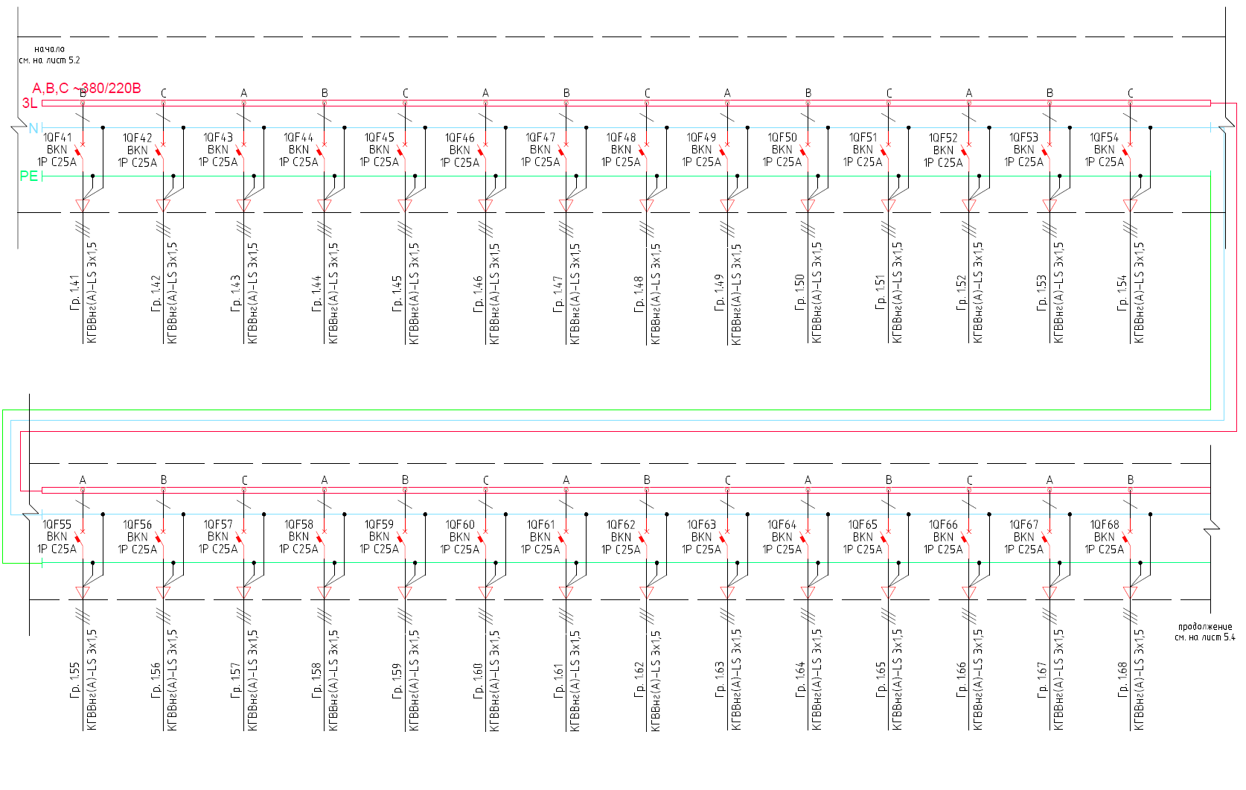
Beginning,
see Sheet 5.2
V

Gr.

Gr.

Gr.

Gr.

Gr.

Gr.

Gr.

Gr.

Gr.

Gr.

Gr.

Gr.

Gr.

Gr.

Gr.

Gr.

Gr.

Gr.

Gr.

Gr.

Gr.

Gr.

Gr.

Gr.

Gr.

Gr.

Gr.

Gr.

Contd.,
see Sheet 5.4

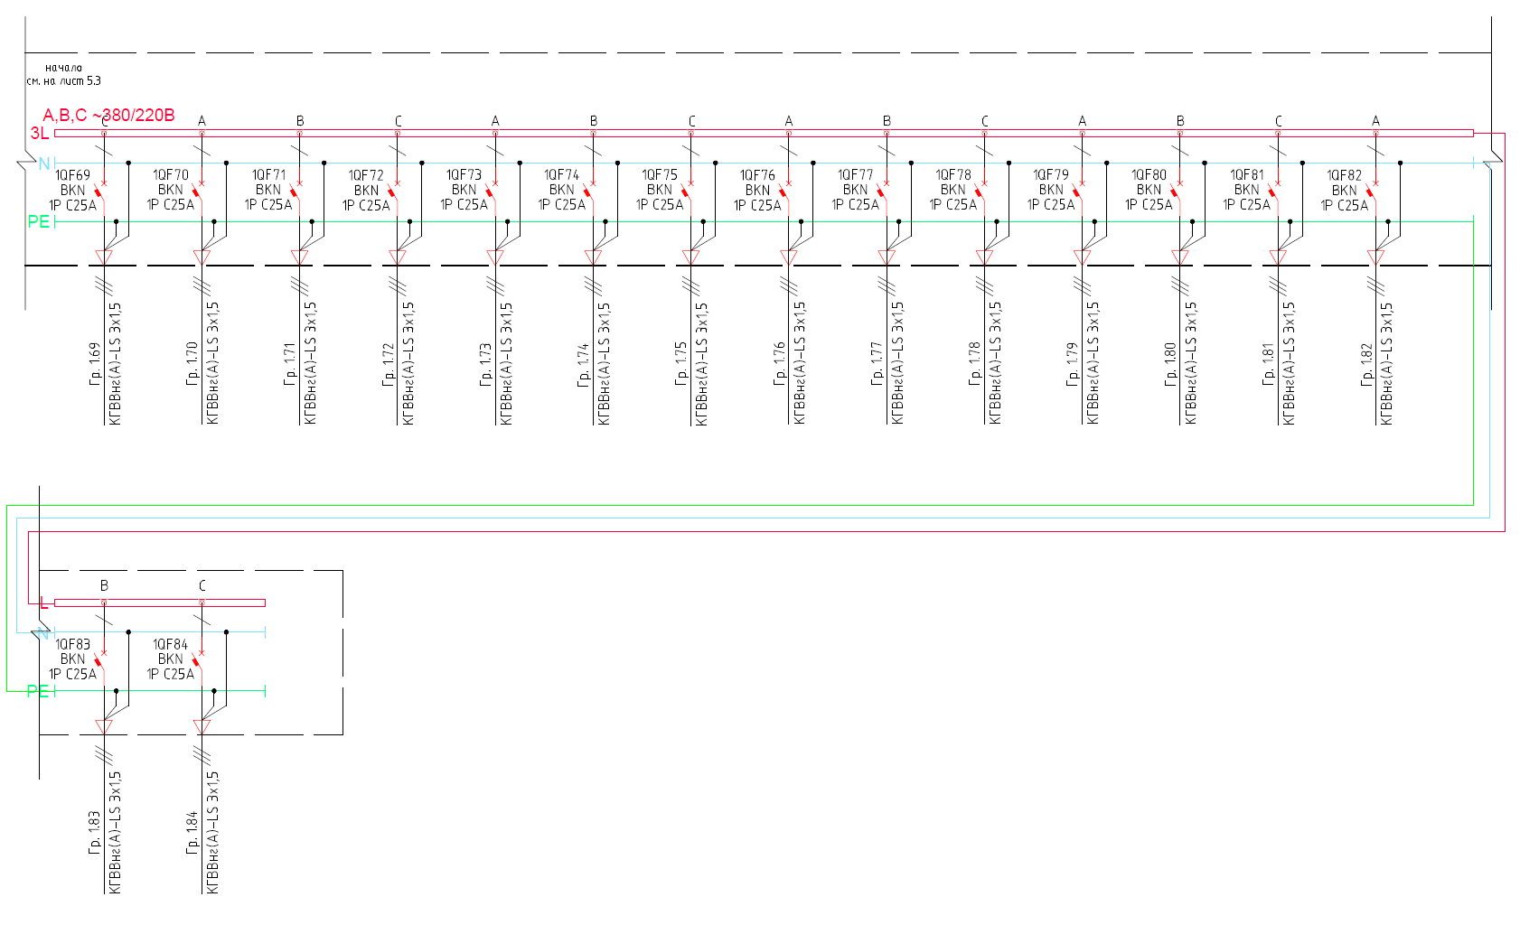

Beginning,
see Sheet 5.3
V

Gr.

Gr.

Gr.

Gr.

Gr.

Gr.

Gr.

Gr.

Gr.

Gr.

Gr.

Gr.

Gr.

Gr.

Gr.

Gr.

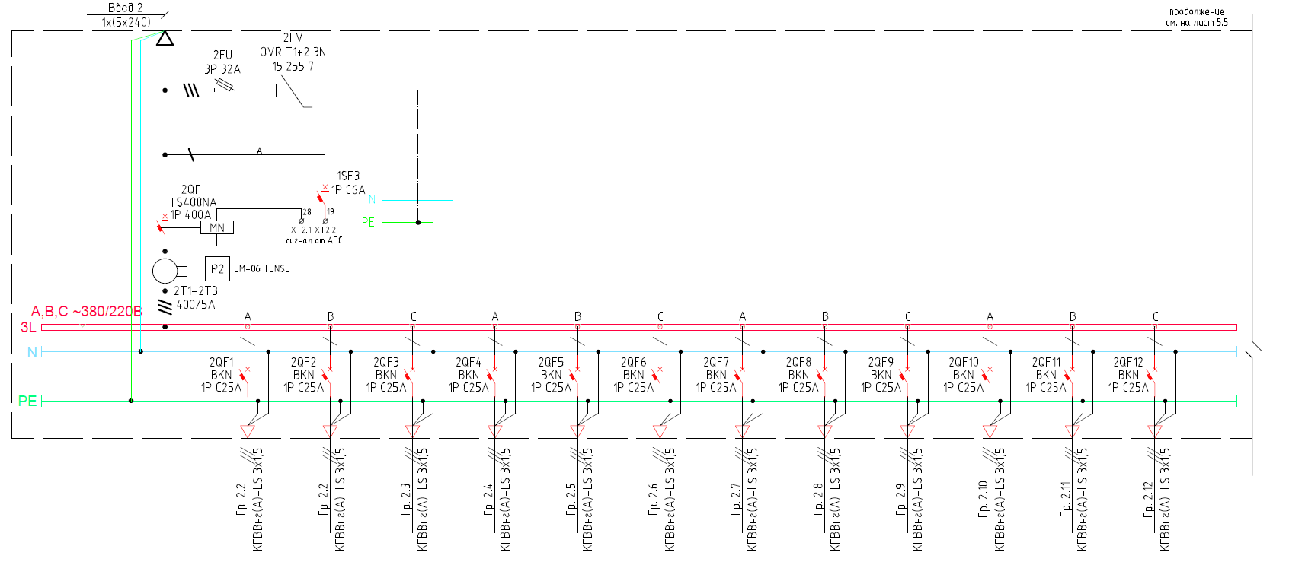
Input 2
Contd.,
see Sheet 5.5
Gr.

Gr.

Gr.

Gr.

Gr.

Gr.

Gr.

Gr.

Gr.

Gr.

Gr.

Gr.

V
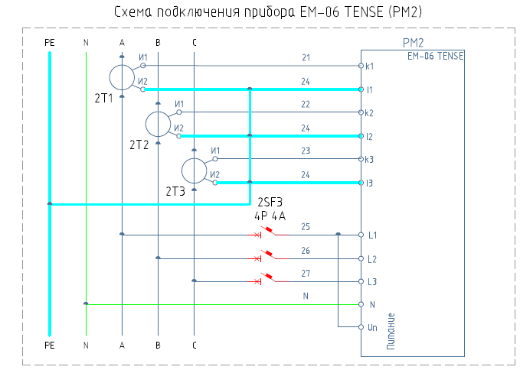
ЕМ-06 TENSE (PM2) Connection Diagram
Power supply

AFAS signal
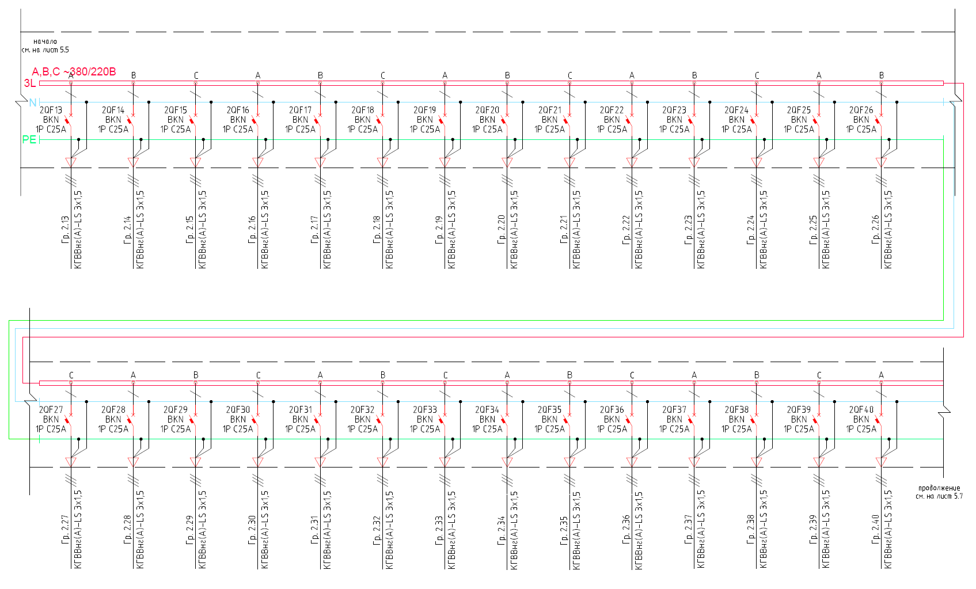
V
Contd.,
see Sheet 5.7
Beginning,
see Sheet 5.5
Gr.

Gr.

Gr.

Gr.

Gr.

Gr.

Gr.

Gr.

Gr.

Gr.

Gr.

Gr.

Gr.

Gr.

Gr.

Gr.

Gr.

Gr.

Gr.

Gr.

Gr.

Gr.

Gr.

Gr.

Gr.

Gr.

Gr.

Gr.

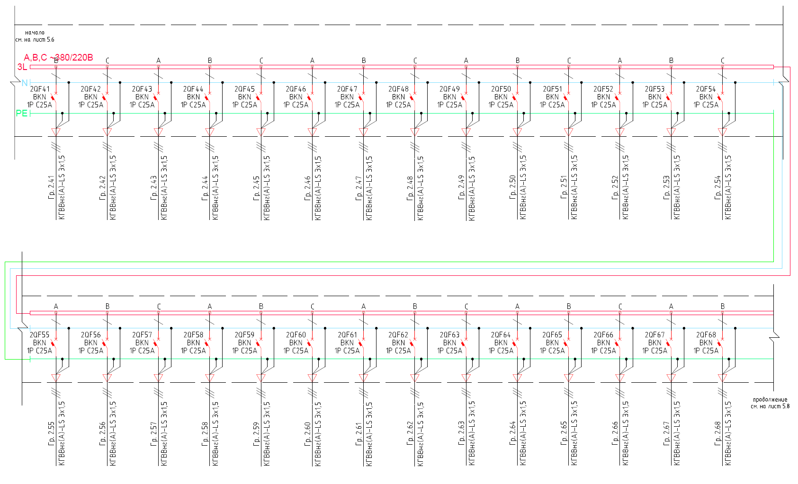
Gr.

Gr.

Gr.

Gr.

Gr.

Gr.

Gr.

Gr.

Gr.

Gr.

Gr.

Gr.

Gr.

Gr.

Gr.

V
Beginning,
see Sheet 5.6
Contd.,
see Sheet 5.8
Gr.

Gr.

Gr.

Gr.

Gr.

Gr.

Gr.

Gr.

Gr.

Gr.

Gr.

Gr.

Gr.

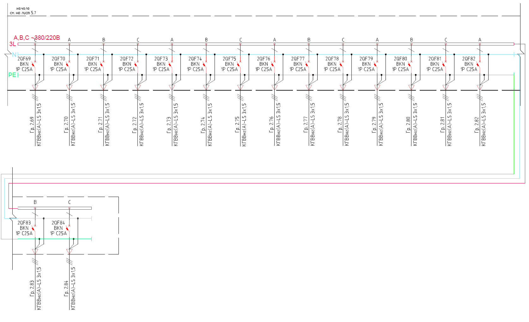
Beginning,
see Sheet 5.7
V
Gr.

Gr.

Gr.

Gr.

Gr.

Gr.

Gr.

Gr.

Gr.

Gr.

Gr.

Gr.

Gr.

Gr.

Gr.

Gr.

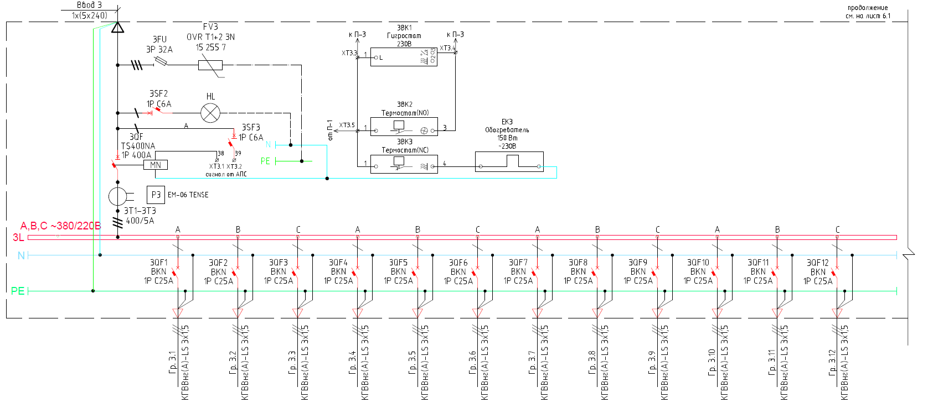
Contd.,
see Sheet 6.1
Input 3
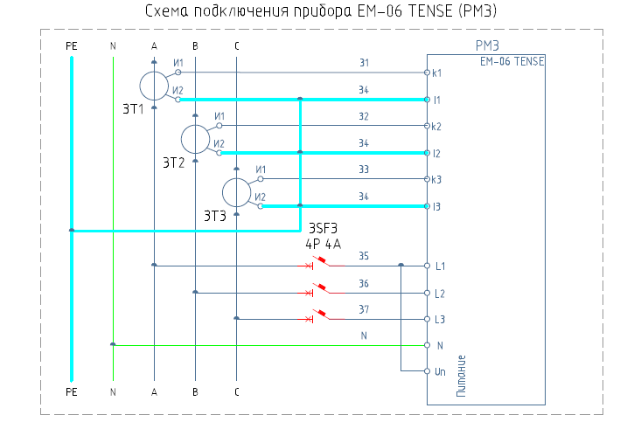
to P-3
from P-1
to P-3
to P-3
Thermostat (NO)
Thermostat (NC)
~230V
150W
Heater
Hygrostat
Power supply

ЕМ-06 TENSE (PM3) Connection Diagram
Gr.

Gr.

Gr.

Gr.

Gr.

Gr.

Gr.

Gr.

Gr.

Gr.

Gr.

Gr.

V
AFAS signal

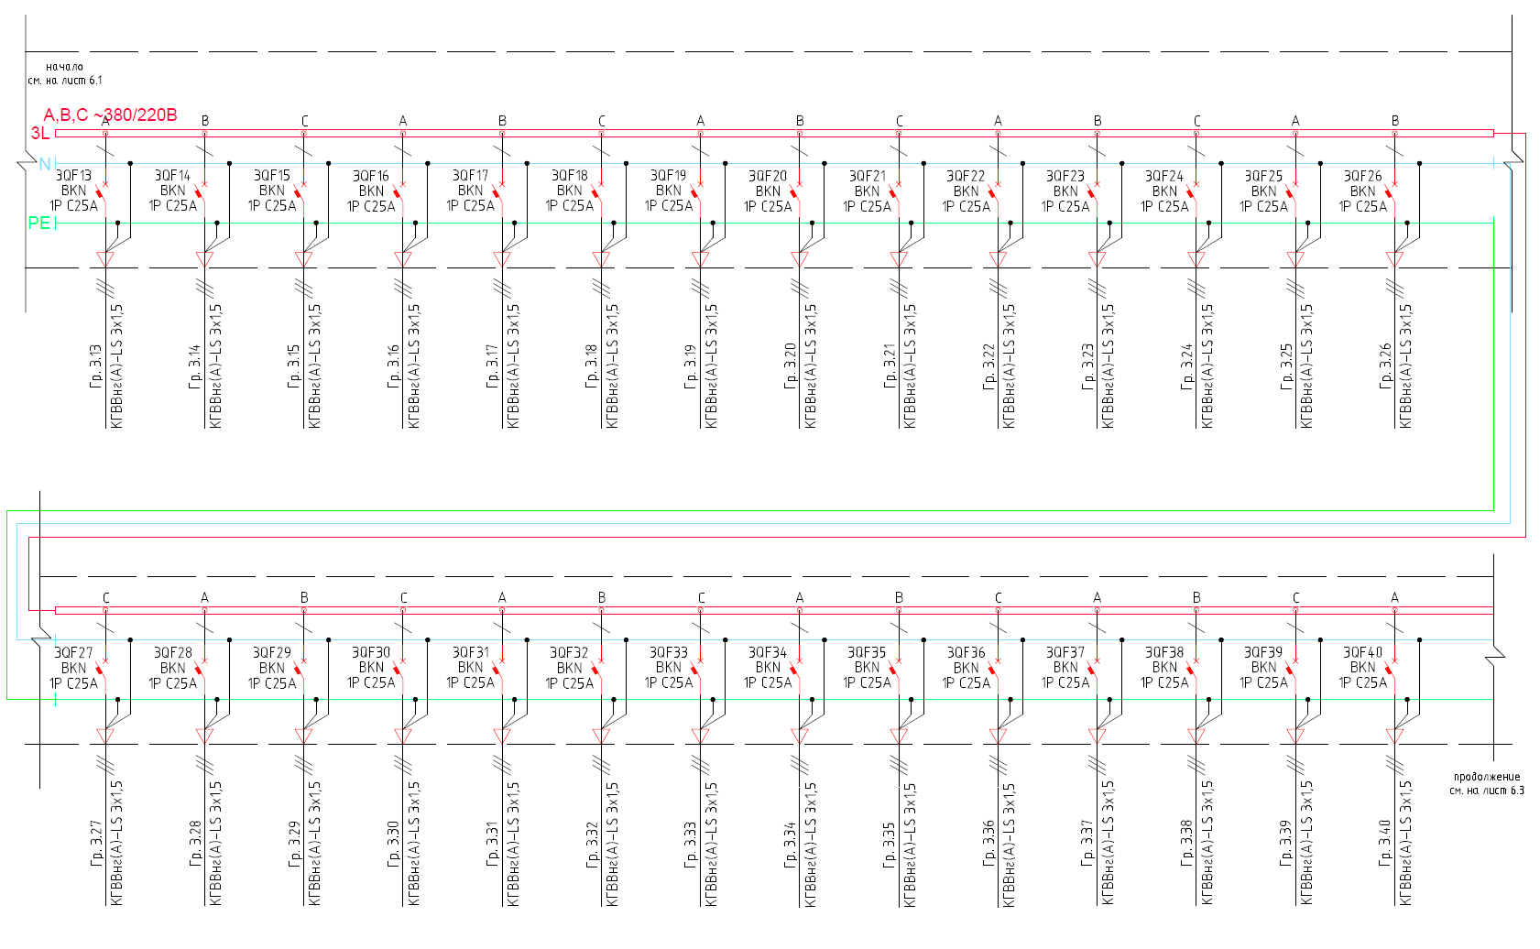
Contd.,
see Sheet 6.3
Gr.

Gr.

Gr.

Gr.

Gr.

Gr.

Gr.

Gr.

Gr.

Gr.

Gr.

Gr.

Gr.

Gr.

Gr.

Gr.

Gr.

Gr.

Gr.

Gr.

Gr.

Gr.

Gr.

Gr.

Gr.

Gr.

Gr.

Gr.

V
Beginning,
see Sheet 6.1

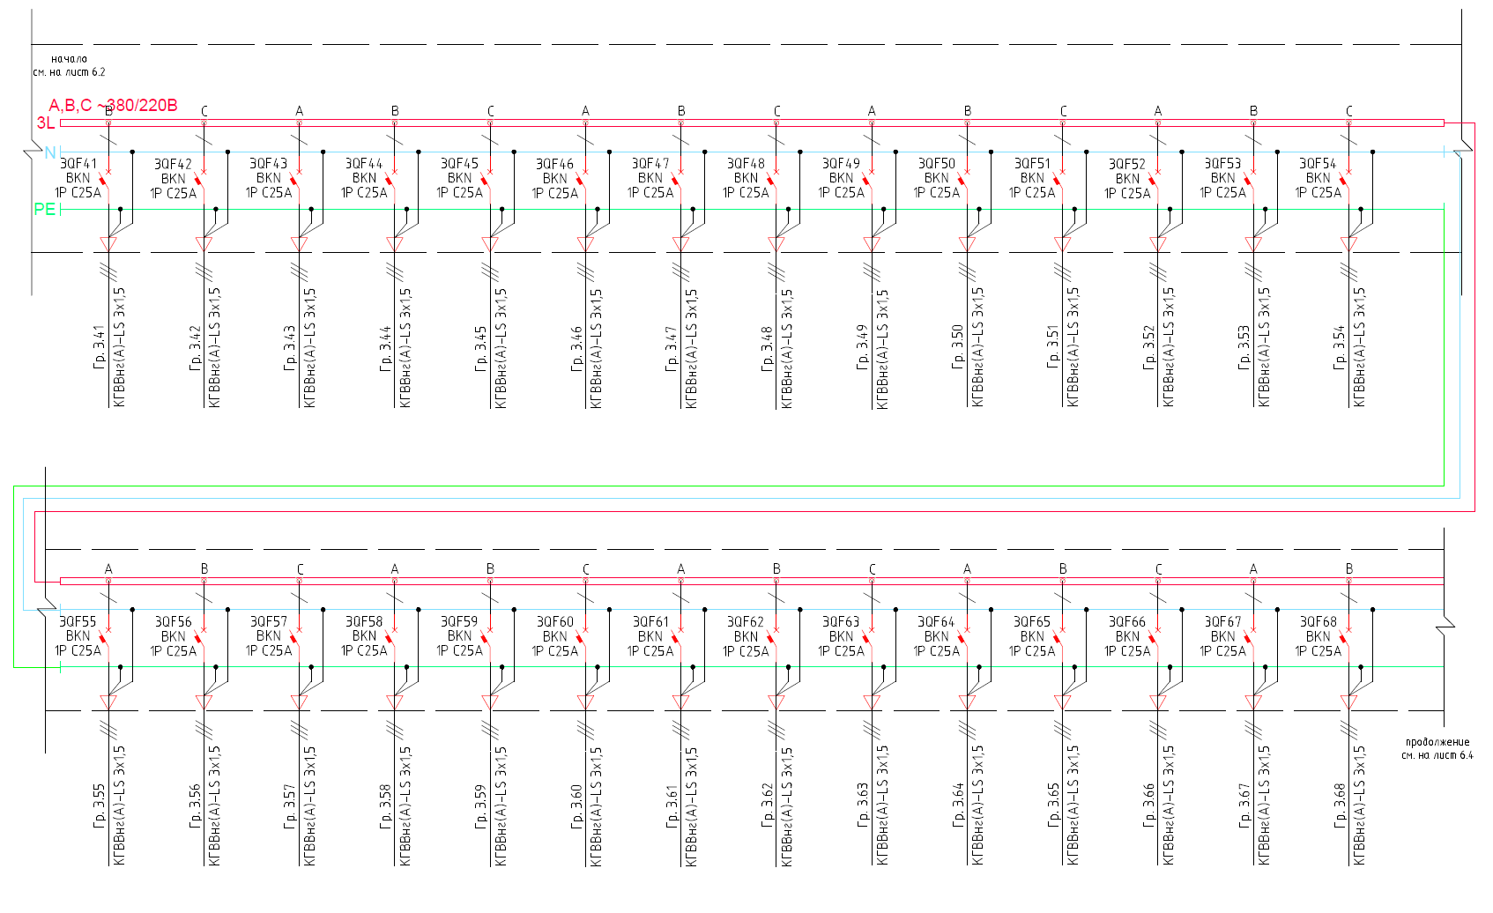
Contd.,
see Sheet 6.4
Gr.

Gr.

Gr.

Gr.

Gr.

Gr.

Gr.

Gr.

Gr.

Gr.

Gr.

Gr.

Gr.

Gr.

Gr.

Gr.

Gr.

Gr.

Gr.

Gr.

Gr.

Gr.

Gr.

Gr.

Gr.

Gr.

Gr.

Gr.

V
Beginning,
see Sheet 6.2

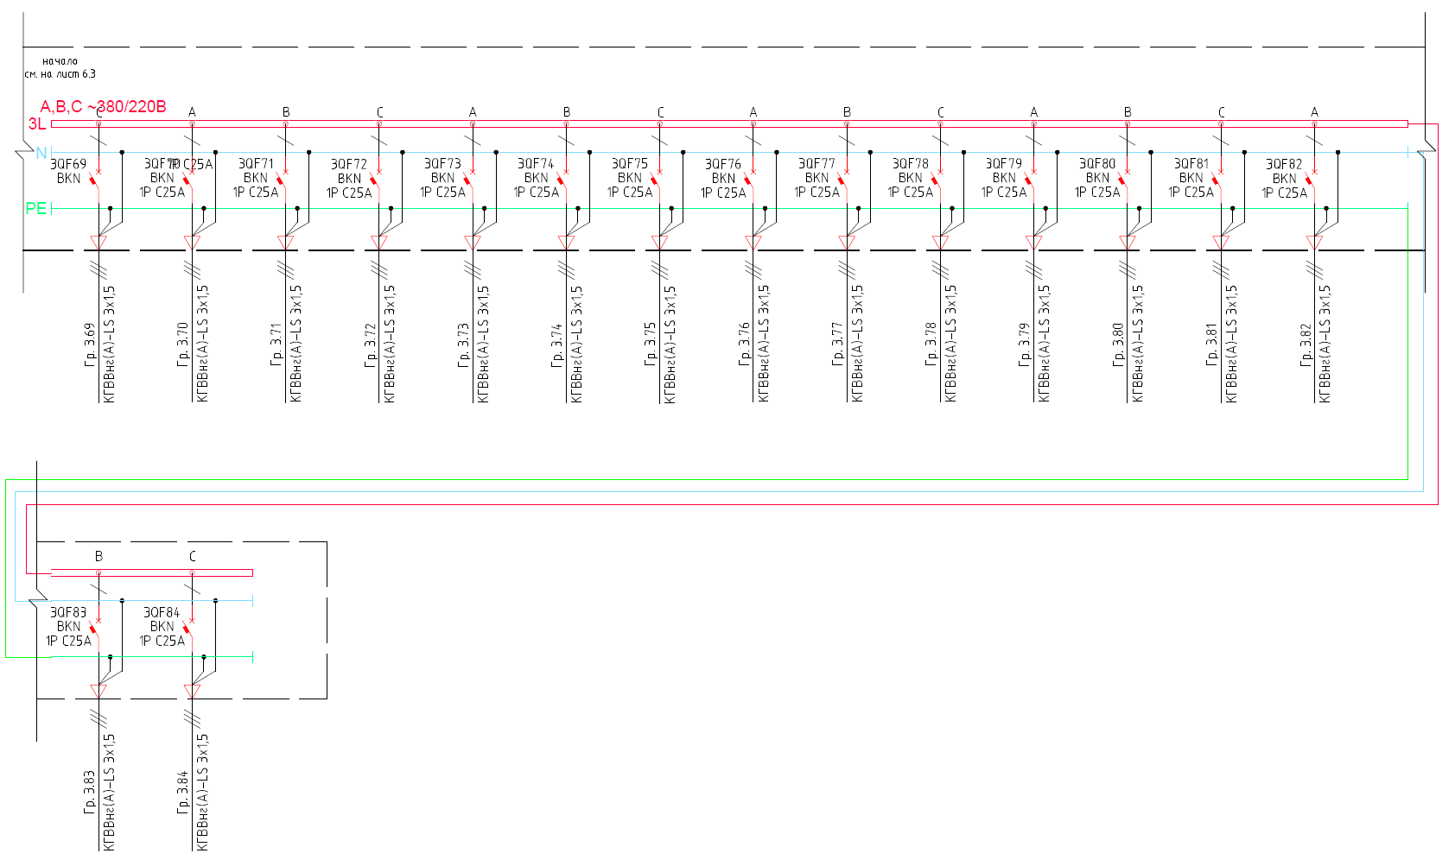
Gr.

Gr.

Gr.

Gr.

Gr.

Gr.

Gr.

Gr.

Gr.

Gr.

Gr.

Gr.

Gr.

Gr.

Gr.

Gr.

V
Beginning,
see Sheet 6.3

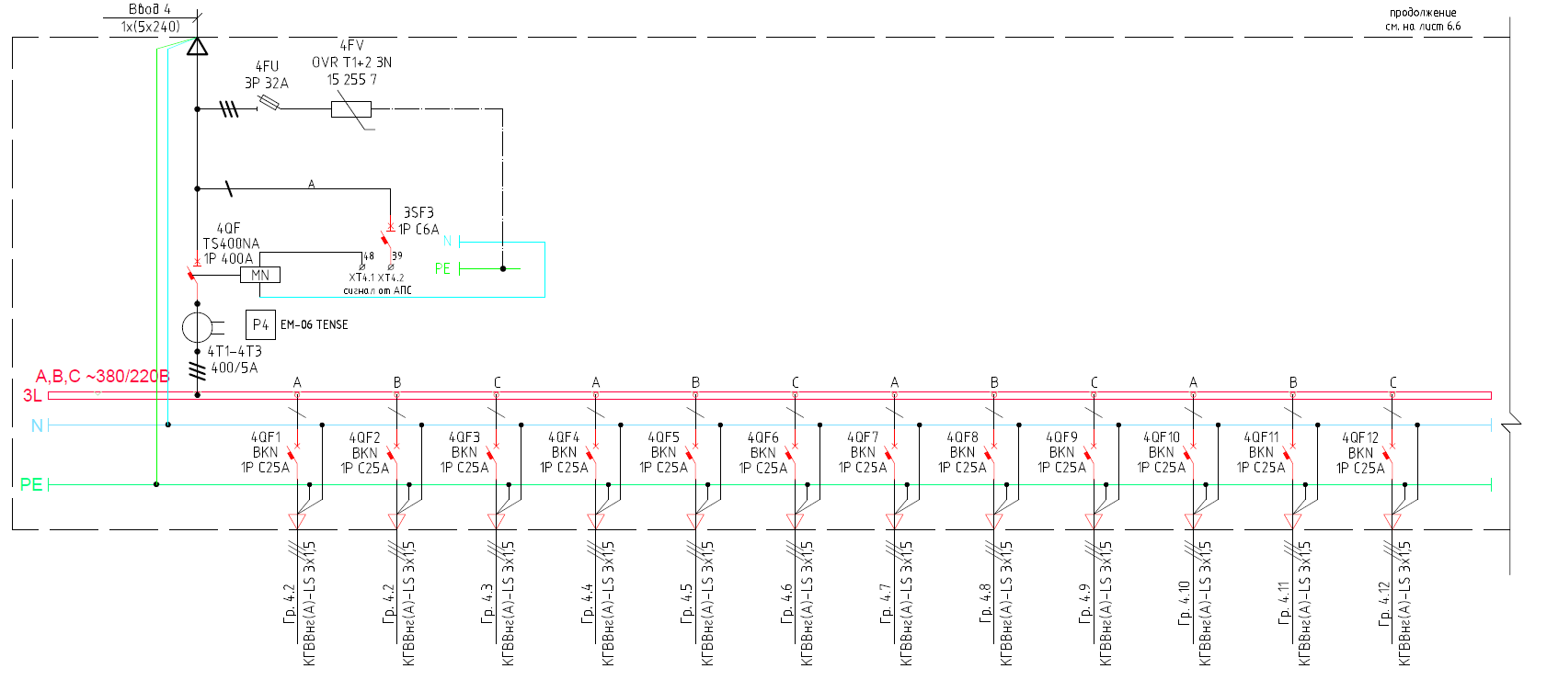
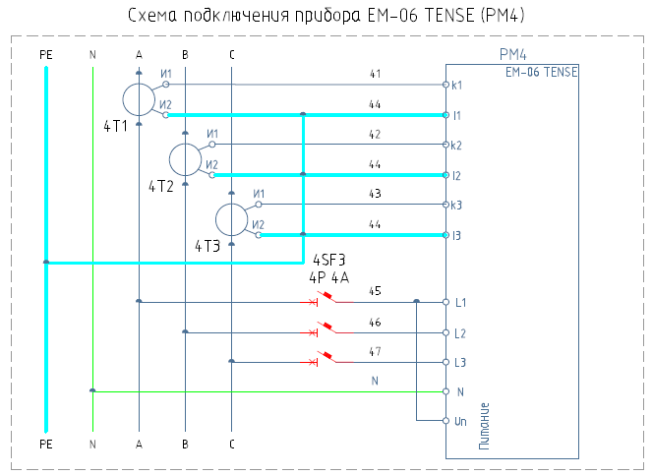
Contd.,
see Sheet 6.6
Power supply

ЕМ-06 TENSE (PM4) Connection Diagram
Gr.

Gr.

Gr.

Gr.

Gr.

Gr.

Gr.

Gr.

Gr.

Gr.

Gr.

Gr.

V
AFAS signal
Input 4

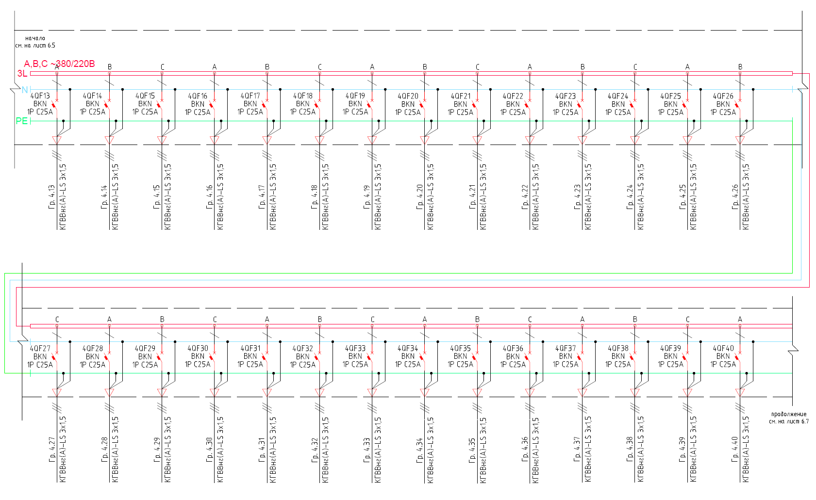
Contd.,
see Sheet 6.7
Gr.

Gr.

Gr.

Gr.

Gr.

Gr.

Gr.

Gr.

Gr.

Gr.

Gr.

Gr.

Gr.

Gr.

Gr.

Gr.

Gr.

Gr.

Gr.

Gr.

Gr.

Gr.

Gr.

Gr.

Gr.

Gr.

V
Beginning,
see Sheet 6.5

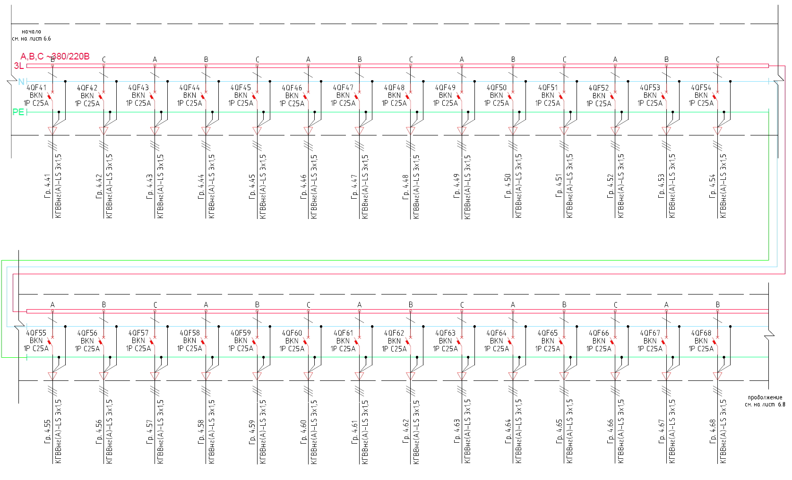
Gr.

Contd.,
see Sheet 6.8
V
Gr.

Gr.

Gr.

Beginning,
see Sheet 6.6
Gr.

Gr.

Gr.

Gr.

Gr.

Gr.

Gr.

Gr.

Gr.

Gr.

Gr.

Gr.

Gr.

Gr.

Gr.

Gr.

Gr.

Gr.

Gr.

Gr.

Gr.

Gr.

Gr.

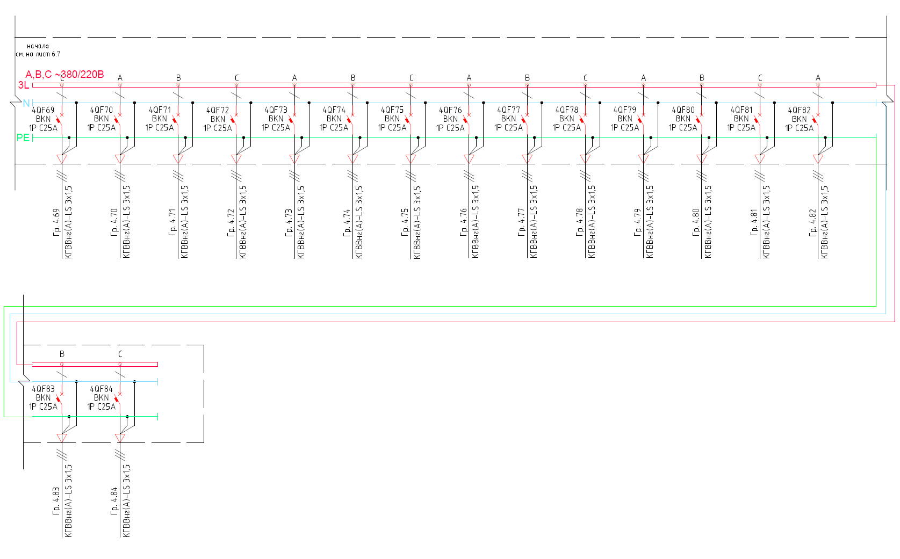
V
Beginning,
see Sheet 6.7
Gr.

Gr.

Gr.

Gr.

Gr.

Gr.

Gr.

Gr.

Gr.

Gr.

Gr.

Gr.

Gr.

Gr.

Gr.

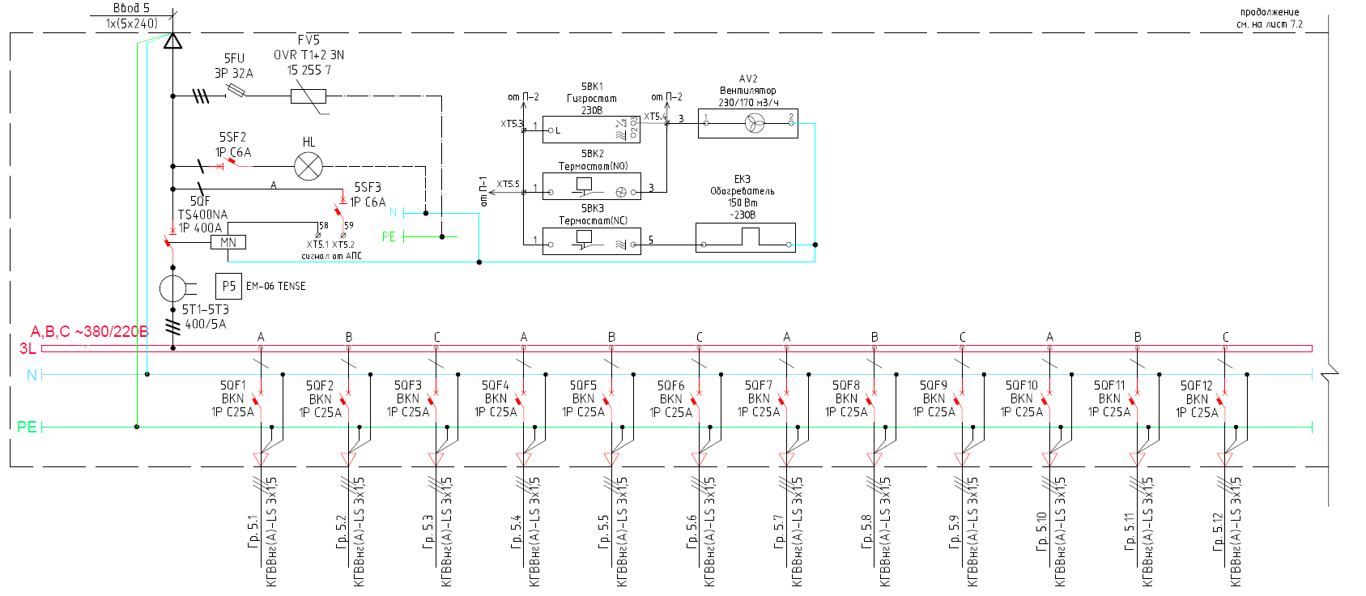
Contd.,
see Sheet 7.2
Input 5
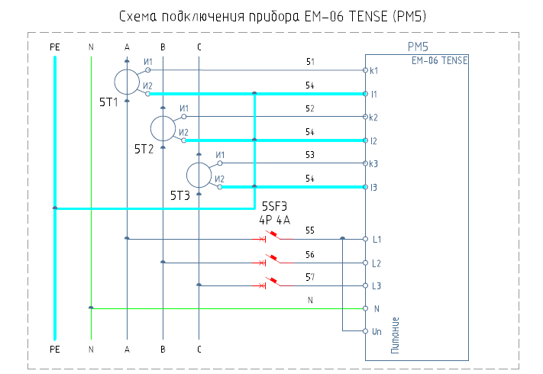
230/170 m³/h
Fan
from P-3
from P-2
Thermostat (NC)
Thermostat (NO)
Hygrostat
230V
~230V
Heater
150W
Power supply

ЕМ-06 TENSE (PM5) Connection Diagram
V
Gr.

Gr.

Gr.

Gr.

Gr.

Gr.

Gr.

Gr.

Gr.

Gr.

Gr.

Gr.

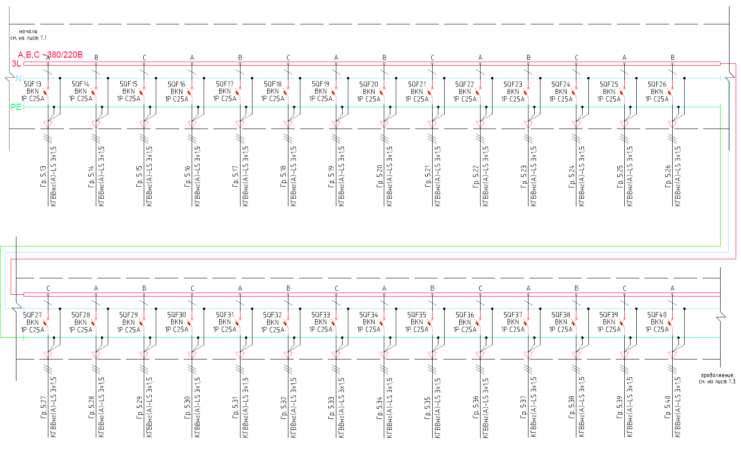
Beginning,
see Sheet 7.1
Contd.,
see Sheet 7.3
Gr.

Gr.

Gr.

V
Beginning,
see Sheet 7.1
Gr.

Gr.

Gr.

Gr.

Gr.

Gr.

Gr.

Gr.

Gr.

Gr.

Gr.

Gr.

Gr.

Gr.

Gr.

Gr.

Gr.

Gr.

Gr.

Gr.

Gr.

Gr.

Gr.

Gr.

Gr.

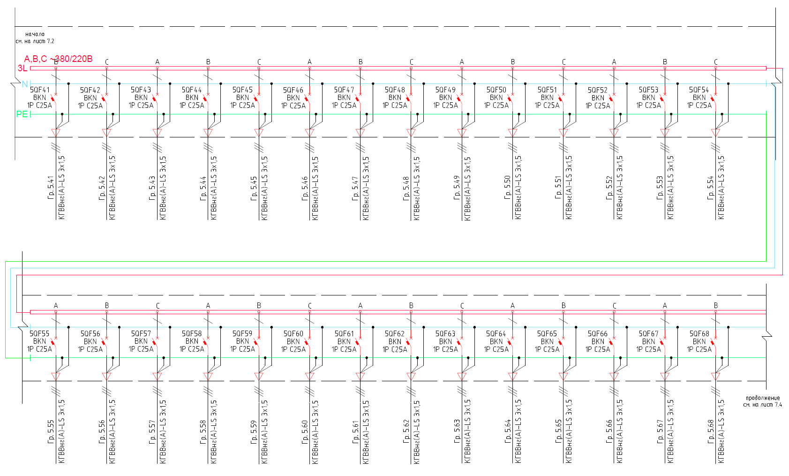
Contd.,
see Sheet 7.4
V
Beginning,
see Sheet 7.2
Gr.

Gr.

Gr.

Gr.

Gr.

Gr.

Gr.

Gr.

Gr.

Gr.

Gr.

Gr.

Gr.

Gr.

Gr.

Gr.

Gr.

Gr.

Gr.

Gr.

Gr.

Gr.

Gr.

Gr.

Gr.

Gr.

Gr.

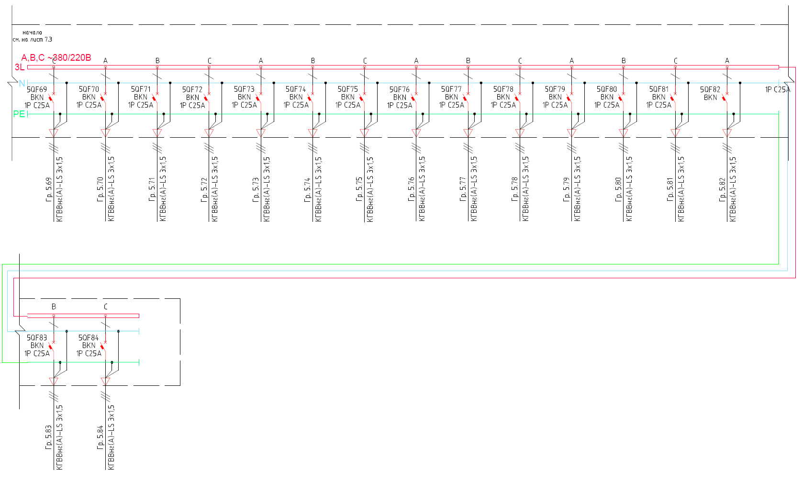
V
Beginning,
see Sheet 7.3
Gr.

Gr.

Gr.

Gr.

Gr.

Gr.

Gr.

Gr.

Gr.

Gr.

Gr.

Gr.

Gr.

Gr.

Gr.

Gr.

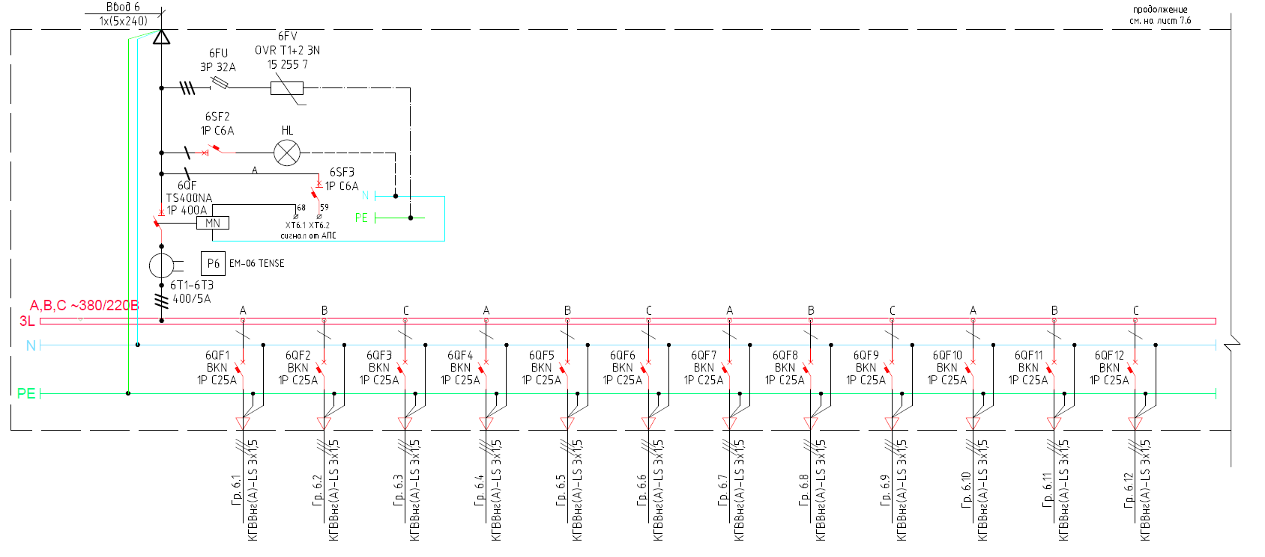
Contd.,
see Sheet 7.6
Input 6
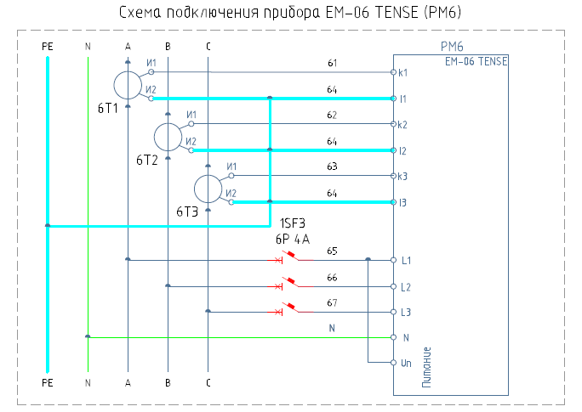
Power supply

AFAS signal
ЕМ-06 TENSE (PM6) Connection Diagram
V
Gr.

Gr.

Gr.

Gr.

Gr.

Gr.

Gr.

Gr.

Gr.

Gr.

Gr.

Gr.

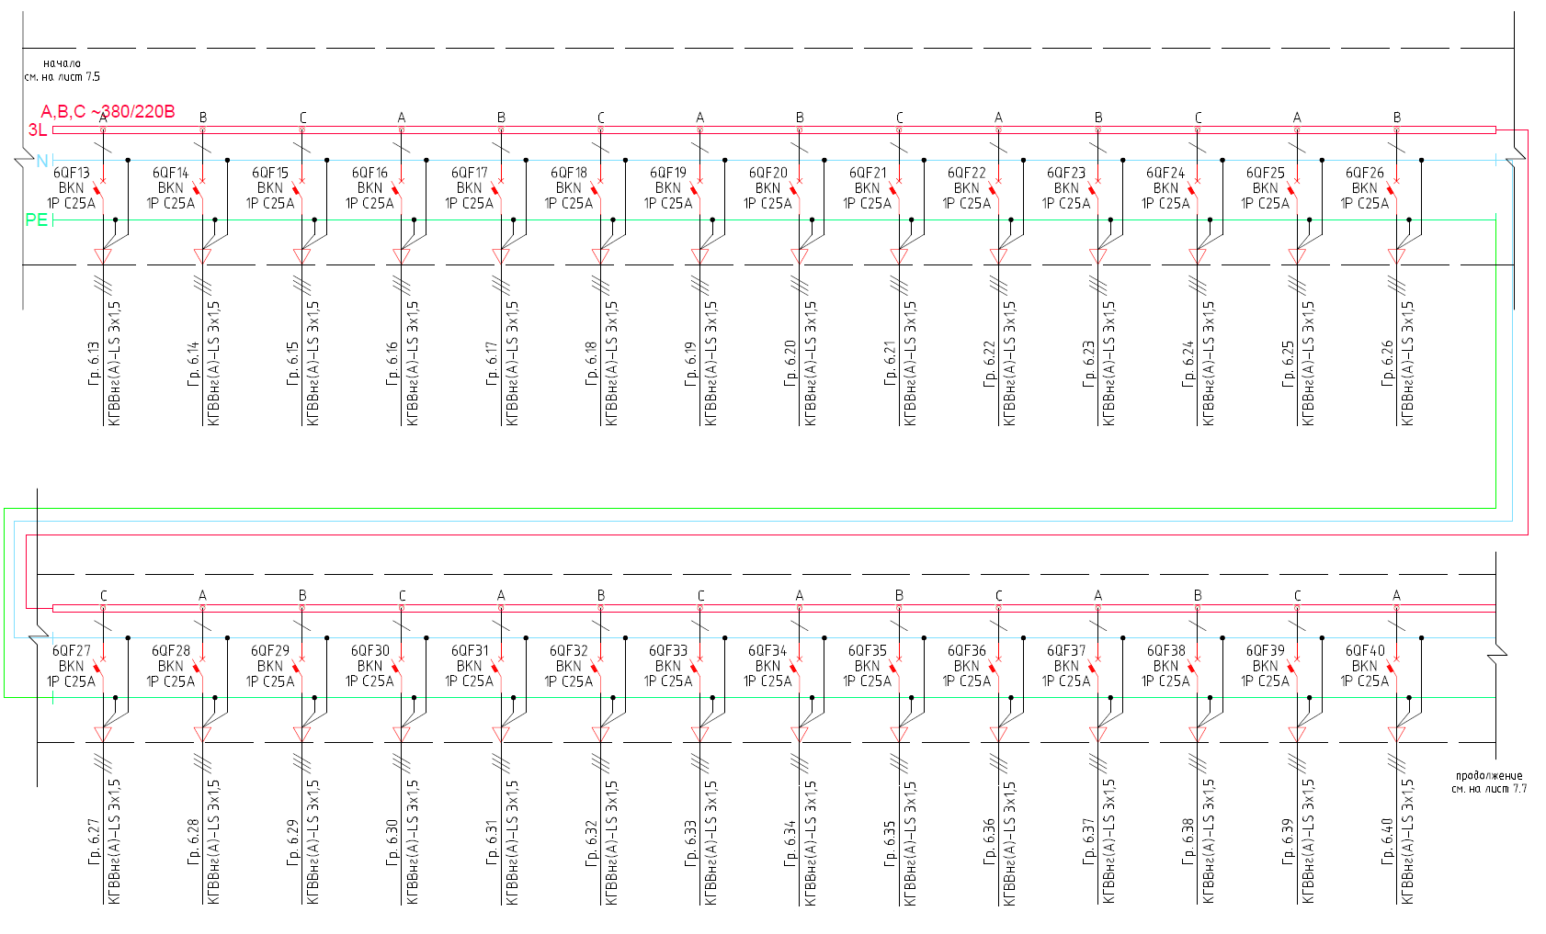
Contd.,
see Sheet 7.7
V
Beginning,
see Sheet 7.5
Gr.

Gr.

Gr.

Gr.

Gr.

Gr.

Gr.

Gr.

Gr.

Gr.

Gr.

Gr.

Gr.

Gr.

Gr.

Gr.

Gr.

Gr.

Gr.

Gr.

Gr.

Gr.

Gr.

Gr.

Gr.

Gr.

Gr.

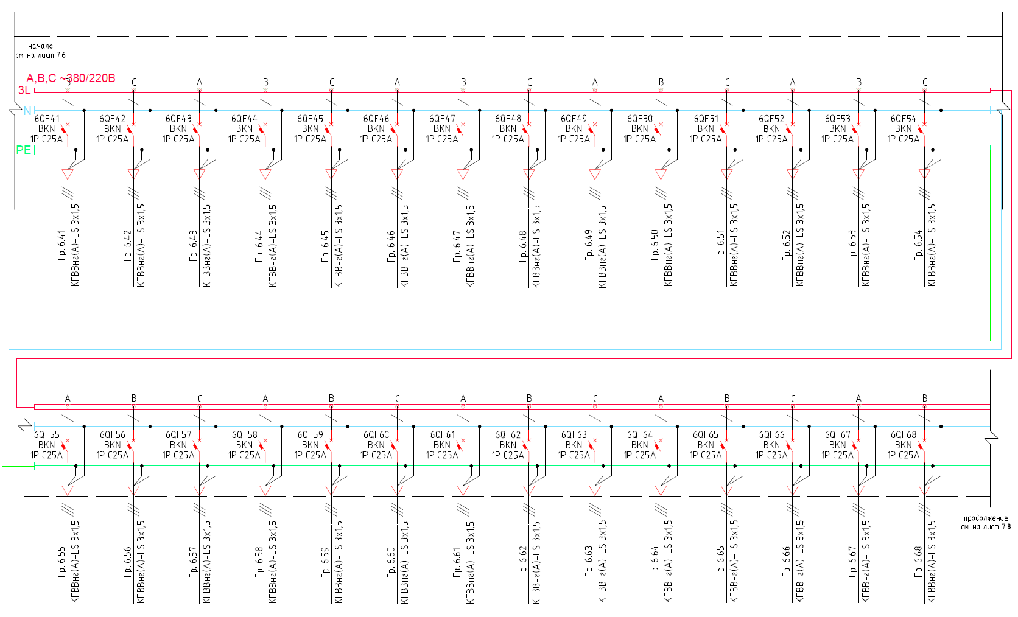
Contd.,
see Sheet 7.8
V
Beginning,
see Sheet 7.6
Gr.

Gr.

Gr.

Gr.

Gr.

Gr.

Gr.

Gr.

Gr.

Gr.

Gr.

Gr.

Gr.

Gr.

Gr.

Gr.

Gr.

Gr.

Gr.

Gr.

Gr.

Gr.

Gr.

Gr.

Gr.

Gr.

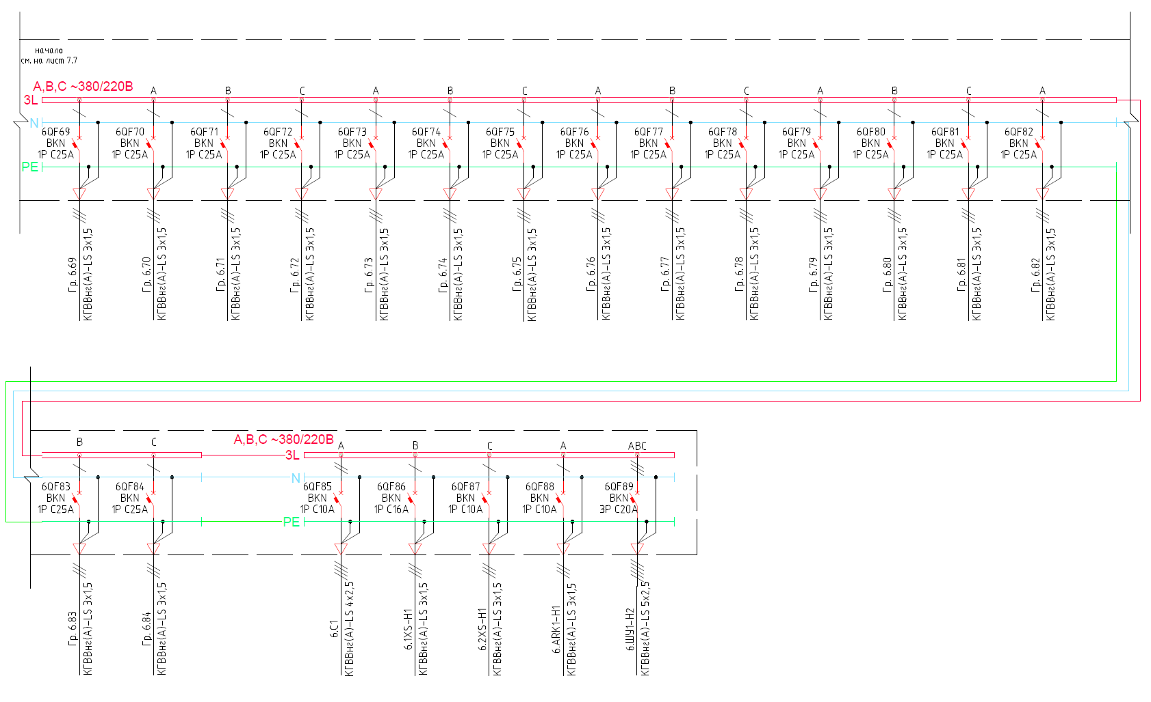
V
V
Beginning,
see Sheet 7.7
Gr.

Gr.

Gr.

Gr.

Gr.

Gr.

Gr.

Gr.

Gr.

Gr.

Gr.

Gr.

Gr.

Gr.

Gr.

Gr.

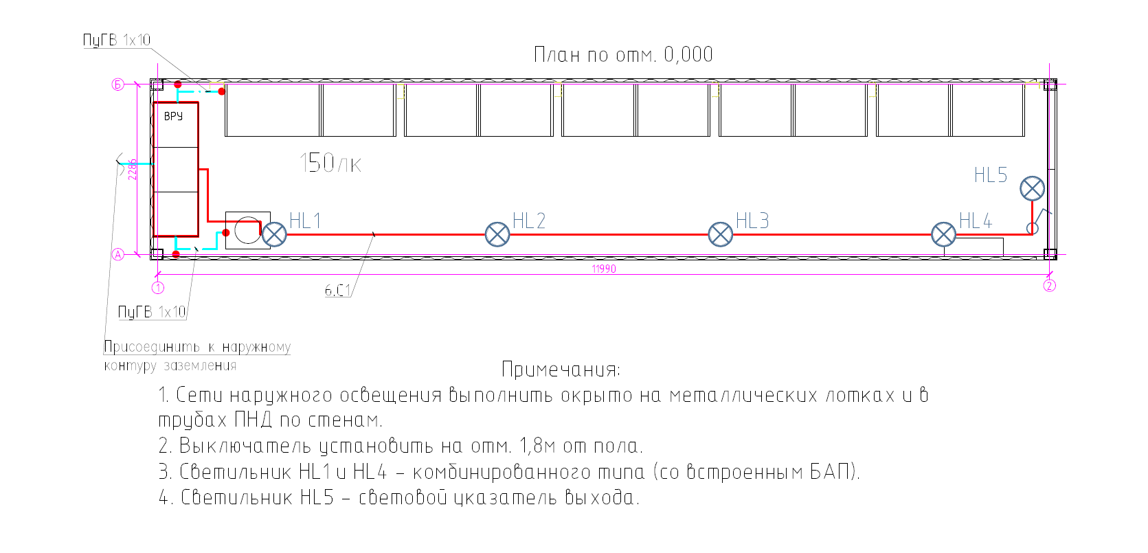
- Outdoor lighting networks should be laid open in metal trays and in HDPE pipes along the walls.
- The circuit breaker to be set up at 1.8 m from the floor.
- The HL1 & HL4 luminaires are combined type (with integrated EPS)
- The HL5 luminaire is the Exit light.
Notes:
grounding circuit
To be connected to the outer
Plan at elev. 0.000

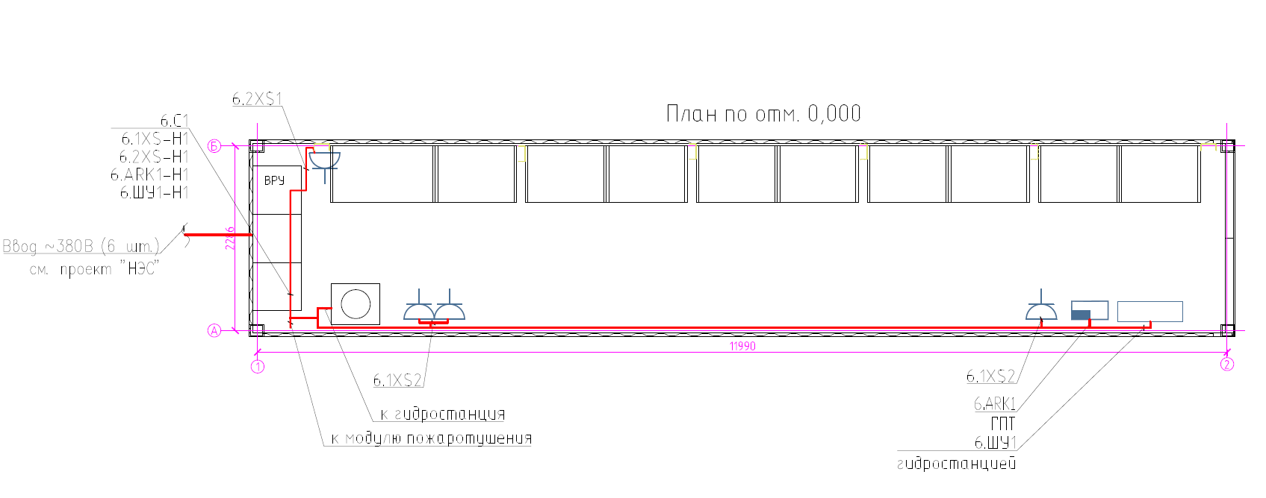
to hydraulic power unit
Hydraulic control cabinet
Input ~380V (6 pcs)
See NES Project
to fire suppression package
Plan at elev. 0.000

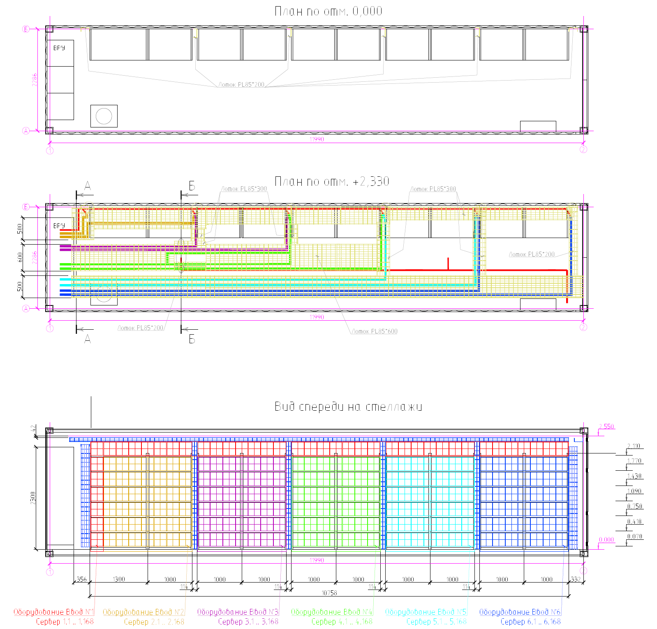
Plan at elev. 0.000
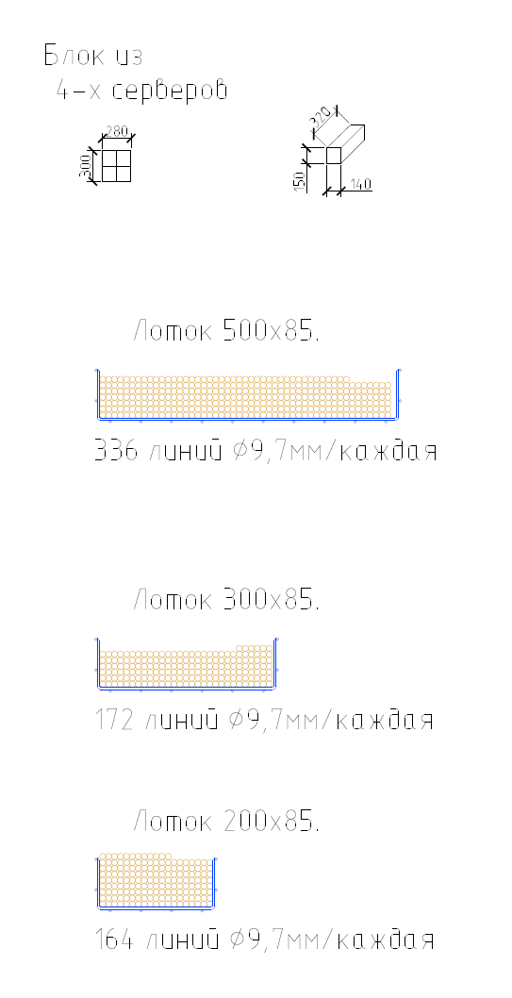
Server

Server

Server

Server

Server

Server

Equipment Input #6

Equipment Input #5

Equipment Input #4

Equipment Input #3

Equipment Input #2

Equipment Input #1

PL85*200 tray

4-server unit
500х85 tray
336 lines ø9.7 mm/each
300х85 tray
172 lines ø9.7 mm/each
200х85 tray
164 lines ø9.7 mm/each
PL85*200 tray

PL85*300 tray

PL85*300 tray

PL85*600 tray

PL85*200 tray

Front view of racks
Plan at elev. +2.330

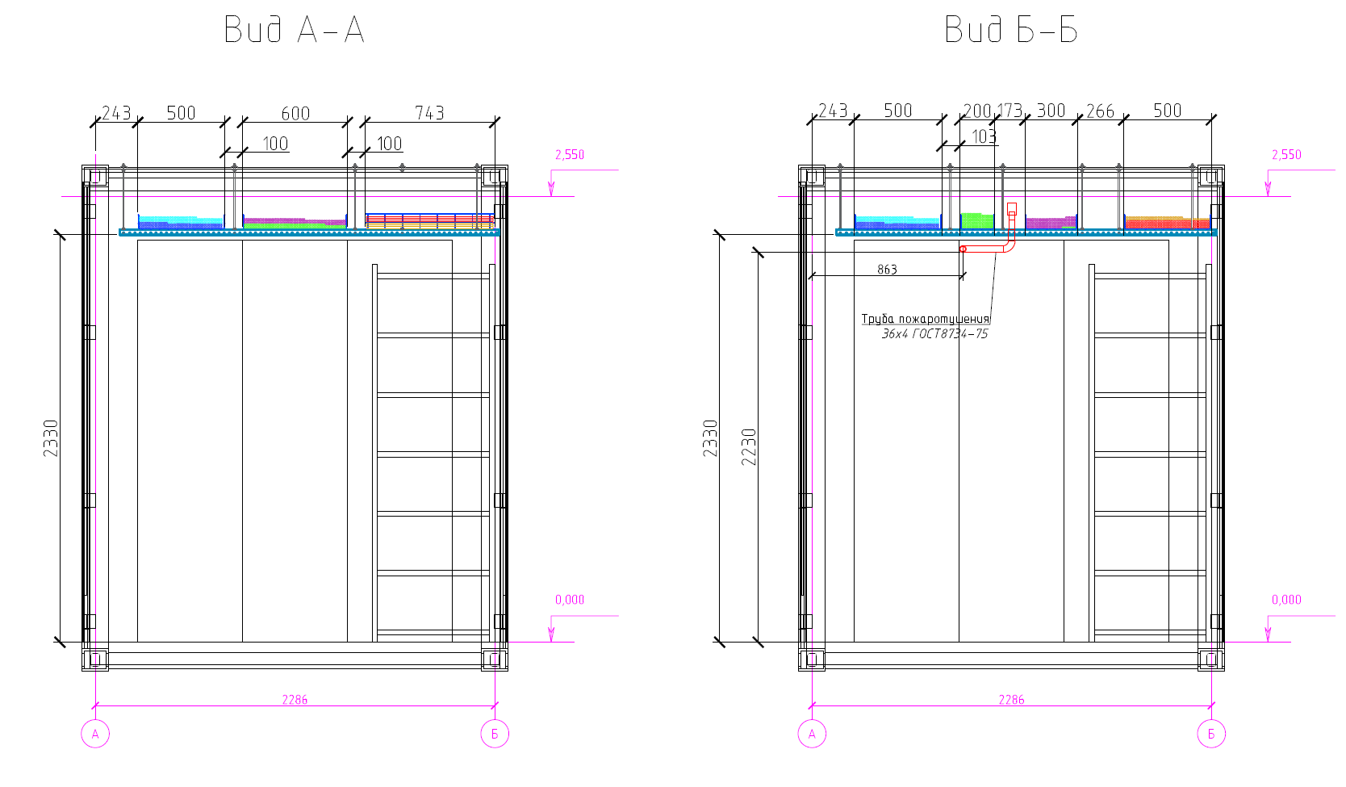

View А-А
View B-B
Fire suppression pipe
Note:
The distance to the trays is indicated from the centerline

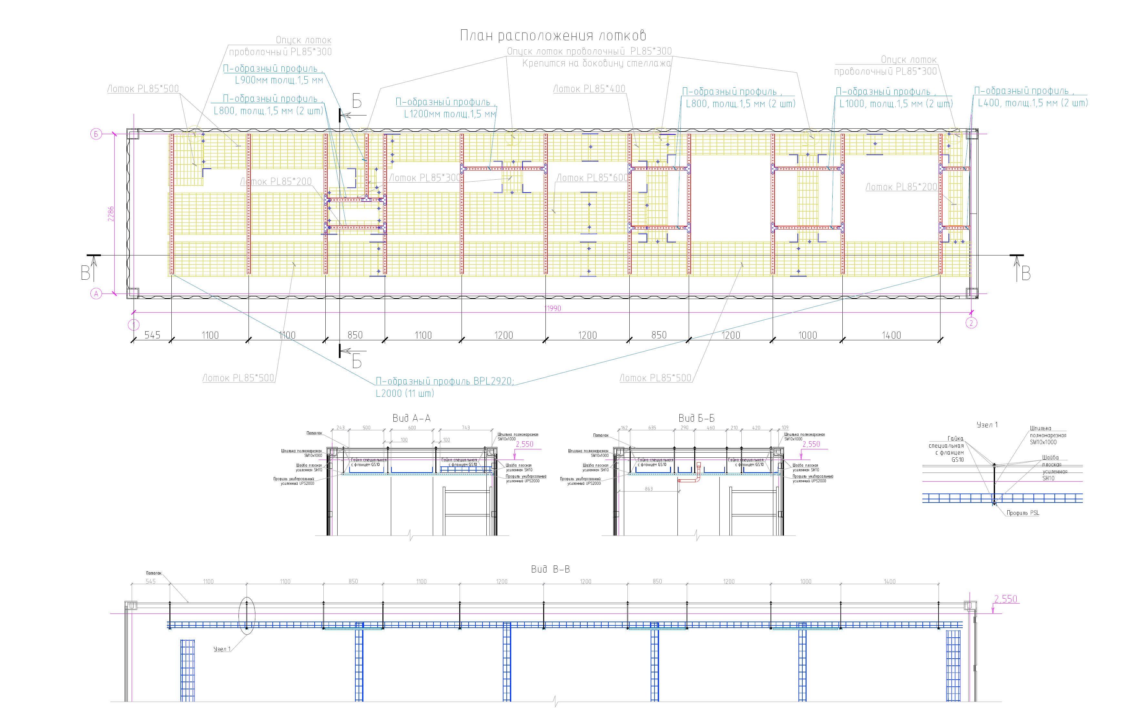
Fully-threaded
UPS2000 reinforced multifunctional channel
Unit 1
SM10x1000 fully-threaded pin
SM10x1000 fully-threaded pin
SM10x1000 fully-threaded pin
SM10x1000 fully-threaded pin
SH10 reinforced flat washer
SH10 reinforced flat washer
SH10 reinforced flat washer
SH10 reinforced flat washer
UPS2000 reinforced multifunctional channel
UPS2000 reinforced multifunctional channel
UPS2000 reinforced multifunctional channel
Ceiling
Ceiling
SH10 reinforced flat washer
Special flange
Nut
pin
PSL channel
PL85*500 tray
Unit 1
View B-B
View А-А
View C-C
BPL 2920 U-channel
L2000 (11 pcs)
Mounted on the sidewall of the rack
L=1200 mm, 1.5 mm thick
L=1000 mm, 1.5 mm thick (2 pcs)
U-channel
L=400 mm, 1.5 mm thick (2 pcs)
U-channel
mesh cable tray
PL85*300 wire
L=800 mm, 1.5 mm thick (2 pcs)
U-channel
PL85*400 tray
PL85*300 wire mesh cable tray
Cable Tray Layout
U-channel
L=800 mm, 1.5 mm thick (2 pcs)
U-channel
L=900 mm, 1.5 mm thick
U-channel
mesh cable tray
PL85*300 wire
PL85*500 tray
PL85*200 tray
PL85*600 tray
PL85*200 tray
PL85*300 tray
PL85*500 tray

