- General Information 2
- Background 2
- Facility Specifications 2
- Lead-in Distributor 2
- Lighting and Socket Network 4
- Grounding 5
- Integrated Cable System 6
- Health, Safety & Environment. Fire Precautions 7
- Construction Organization 8
- Operation Organization 8
- Environmental Protection 9
- Electric Power Metering 9

1 General Information
The "Mobile Data Processing Center" detailed design was carried out on the basis of the terms of reference issued by the customer.

2 General provisions
This detailed design is being developed for the purpose of supplying power to process equipment located in a mobile container.
The detailed design provides for the following scope of work on developing a power supply system for this facility:
- LID installation;
- Installation of cable support systems;
- Erection of the server power supply line;
- Erection of the hydraulic power supply line;
- Installation of container electrical lighting equipment;
- Installation of power supply equipment for the fire suppression system;
- Installation of sockets for adjustment equipment.
3 Facility Specifications
3.1 Location
The mobile container can be located in a non-seismic area, on the street, on a dedicated foundation, in any place that meets the environmental requirements for the equipment operation.

4 Lead-in Distributor
A lead-in distributor 0.4 kV (hereinafter referred to as LID) is used to connect equipment to the transformer substation supply lines. The LID consists of 3 panels; each panel features 2 sections.
In total, it is possible to connect six inlets with a 5x240 sq.mm cable. No provision is made for the mutual redundancy of inputs. The Susol 400A circuit breakers are used as input protection devices.
Each output line panel is a block of circuit breakers and busbar distributors N and Pe. Each panel is capable of serving up to 168 servers. The P-3.2 panel has output groups for lighting, fire suppression, and hydraulic equipment.
To ensure the nominal temperature regime of the protection devices, each LID section consists of a thermostat, a heater, and a fan.
Six (6) Tense EM-06 panel-mount three-phase digital multimeters are used to monitor the load of each LID section.
Incoming circuit breakers are equipped with undervoltage tripping devices. Once an automatic fire suppression system receives a signal, a command pulse will be sent to the hydraulic power unit to close the ventilation doors of the container, followed by deenergization of the server equipment after the time required for closing has elapsed.
LID load calculation is given in Table 1

Table 1
Description | Pins, kW | Ku | cos f | tg f | Pest, kW | Qest, kVAr | Sest, kVA | Iest, A
Input 1 (servers 168 pcs) | 193.2 | 1 | 0.85 | 0.62 | 193.2 | 119.78 | 227.32 | 345.34
Input 2 (servers 168 pcs) | 193.2 | 1 | 0.85 | 0.62 | 193.2 | 119.78 | 227.32 | 345.34
Input 3 (servers 168 pcs) | 193.2 | 1 | 0.85 | 0.62 | 193.2 | 119.78 | 227.32 | 345.34
Input 4 (servers 168 pcs) | 193.2 | 1 | 0.85 | 0.62 | 193.2 | 119.78 | 227.32 | 345.34
Input 5 (servers 168 pcs) | 193.2 | 1 | 0.85 | 0.62 | 193.2 | 119.78 | 227.32 | 345.34
Input 6 (servers 168 pcs) | 193.2 | 1 | 0.85 | 0.62 | 193.2 | 119.78 | 227.32 | 345.34
Lighting | 0.06 | 1 | 0.9 | 0.48 | 0.06 | 0.03 | 0.07 | 0.31
Hygrostat system | 0.15 | 1 | 1 | 0 | 0.15 | 0 | 0.15 | 0.69
Hydraulic power unit | 7 | 0.8 | 0.7 | 1.02 | 5.6 | 5.71 | 8 | 12.16
Socket group | 2 | 0.8 | 0.95 | 0.33 | 1.6 | 0.53 | 1.69 | 7.66
Network equipment | 2 | 1 | 0.9 | 0.48 | 2 | 0.96 | 2.22 | 10.11
Total: | 1170.41 |  |  |  | 1168.61 | 725.91 | 1376.05 | 2102.97

Emergency Mode
Emergency operation of the electrical installation is not assumed. In the event of an accidental loss of voltage on one or more of the inputs, the corresponding number of servers will be disconnected.
5 Lighting and Socket Network

  - Main Design Decisions
Lighting has been designed on the basis of EIC, Section 6. Lighting standards for premises have been adopted as per SNiP 23-05-95 and SP 31-110-2003.
The container provides for both working and combined lighting.
The lighting supply voltage is 380/220 V. Luminaires and sockets are supplied from 220 V using three-wire lines.
A КГВВГнг(А)-LS (NYM-O (N)YM(St)) three-core cable of the required cross-section with pull boxes is used for branch circuits of all types of lighting and the socket network. The equipment is connected via the TN-C-S grounding system.
A self-contained PE zero protective conductor is used to connect the metallic non-conductive parts of the lighting unit. Avoid combining PE zero protective conductor and the working N neutral conductor in a three-wire network.
The lighting network calculation is carried out by loss of voltage at the most remote point from the sources, followed by checking for the permissible load current. The loss of voltage from the panel to the farthest luminaire does not exceed 5%.

  - Working Lighting
The container working lighting uses IP54 luminaires with fluorescent lamps. The lighting has manual control using a switch installed at an elevation of 1,700 m.
  - Emergency Lighting
The emergency lighting is divided into safety and evacuation lighting.
The safety and evacuation lighting standards have been adopted as per SNiP 23-05-95.
A combined emergency luminaire with an inscription "Exit" is installed above the exit from the container. If there is a voltage in the network, the light is supplied from it and recharges the built-in battery. When the power is off, the light operates from the battery.
Two of the four main working lights are equipped with built-in emergency power supplies. If there is a voltage in the network, the light operates as regular working lighting and recharges the built-in battery. When the power is off, the light turns on and operates from the battery.
  - Socket Network
The container provides for the installation of 220 V sockets intended for auxiliary equipment.
Electrical sockets are installed on the container walls at an elevation of 1,000 m. Electrical sockets have an IP54 rating and are equipped with a protective cover.
  - Electric Power Distribution
Electric lighting and socket network are supplied from the P-3.2 panel of the planned LID.

6 Grounding
To protect the maintenance personnel from electrocution, the container features inner grounding circuit according to EIC, Sec. 1.1. The inner grounding circuit is connected to the outer grounding circuit at two points. Enclosures of electrical equipment, cable support structures, panel products and other exposed conductive parts that are not energized during the normal operation of the electrical installation are connected to the inner grounding circuit.
According to EIC, Sec. 1.1, the TN-C-S grounding system is used, which has its zero protective conductor and neutral conductor functions combined in a single conductor from the transformer to the LID.
The TN-C-S grounding system is designed with a zero protective bus (PE) and a neutral bus (N). All six inputs are supplied from a four-wire circuit. The N lead-in conductor is connected to the PE bus at the input panels.
7 Integrated Cable System
PVC-insulated flame-retardant (for bunched wiring) КГВВГнг(А)-LS (NYM-O (N)YM(St)) 3х1.5 copper-conductor cables are used where specifically requested by the Customer. Server power supply cables are laid in the wire mesh cable trays.
A КГВВГнг(А)-LS (NYM-O (N)YM(St)) 5х2.5 cable is used to supply the hydraulic power unit. A КГВВГнг(А)-LS (NYM-O (N)YM(St)) 4x1.5 cable is used to supply the lighting groups.
A fire-resistant flame-retardant ВВГнг(А)-FRLS (NYY-O) cable with low smoke and gas emission is used to supply the fire suppression system. The cable is laid in a corrugated PVC pipe.

8 Health, Safety & Environment. Fire Precautions
For the reconstruction and operation of the designed facility, health, safety & environment (HSE) is ensured by taking all design decisions in strict compliance with the "Electrical Installations Code", SNiP 12-03-2001 "Occupational Safety in Construction", POT RM-016-2001 "Interindustry Labor Safety Rules (Safety Rules) in the Operation of Electrical Installations" (as amended as of July 1, 2003).
Persons having at least an electrical safety group III can be admitted to work.
In accordance with the current technological design standards, the detailed design provides for the following action framework to ensure HSE:

- Use of products having certificates in the established standard form;
- Use of machines and mechanisms having HSE principles laid down in their design in the performance of construction and assembly work;
- Grounding of all normally dead metal structures, which may become live as a result of an emergency in electrical circuits;
- Installation of earthing arrangements with a standardized resistance value and a design that complies with the requirements of SNiP 3.05.06-85 "Electrotechnical Installations";
- Use of high-scale mechanical operations;
- Enclosure of conductive parts at an accessible height (the use of enclosed boards, panels);
- Before starting any installation work, the availability and correctness of the necessary hoisting mechanisms, tools, protective equipment, and safety devices must be checked;
- The equipment installation work shall be performed after complete removal of voltage from the conductive parts of the distributor.
The Customer's operational personnel is responsible for the site preparation, installation of guards, safety signs, as well as for the issuance of permits to work to the team.
The electrical installation work must be carried out in strict compliance with the requirements of EIC, SNiP 3.05.06-85 "Electrotechnical Installations".

- Construction Organization
The section has been prepared on the basis of SNiP 12-01-2004 "Organization of Construction". The delivery of materials and equipment is carried out in accordance with the transport scheme.
The whole range of construction and assembly work must be performed in compliance with the requirements of SNiP 12-03-2001 "Occupational Safety in Construction", as well as POT RM-016-2001 "Interindustry Labor Safety Rules (Safety Rules) in the Operation of Electrical Installations" (as amended as of July 1, 2003). In addition, all requirements for the organization of the team's admission, the qualification of the maintenance personnel must be met at work.
Construction waste shall be picked up and disposed of by the organization responsible for the performance of construction and assembly work.

- Operation Organization

In accordance with the "Instruction on the Procedure for Clearing New and Reconstructed Electrical Installations for Operation", the Rostekhnadzor bodies shall draw up a certificate of clearance of energy units for operation and issue a permit to energize the energy unit on the basis of the decision taken by the acceptance committee.
The certificate of clearance of the energy unit for operation shall be prepared following consideration of the documentation provided by the owner (Customer) and inspection of the electrical installation by the Rostekhnadzor's inspector.
The permit to energize (connect) the energy unit shall be issued in writing by the territorial administration of Rostekhnadzor subject to an electricity supply contract between the consumer and the electric power provider. The energy unit shall be connected in the established manner within 5 (five) days as from the date of issue of the permit.
The operation of electrical installations is organized in accordance with the following regulatory documents:
- Interindustry Labor Safety Rules (Safety Rules) in the Operation of Electrical Installations;
- Instruction on the work-related duties of the person responsible for the electrical facilities;
- The conditions reflected in the "Act on the Separation of Ownership and Responsibility for the Operation of Electrical Installations between the Electric Power Provider and the Consumer".
During the operation, inspections, checks, preventive measurements, routine and major repairs are carried out aimed at ensuring their reliable operation, maintaining and complying with the requirements of the relevant section of EIC (7th ed.).

11 Environmental Protection
The electric power supply of the container has zero emissions and excludes any harmful environmental emissions (both air and water). There is no industrial noise and vibration. Therefore, the detailed design provides for no air and water protection measures to reduce industrial noise and vibration.

12 Electric Power Metering
The commercial electric power metering is carried out at the transformer substation.
Tense EM-06 multimeters are used to organize technical monitoring of electric power supply parameters.

General

- The detailed design of the fire suppression system has been prepared in accordance with the requirements:
Federal Law of the Russian Federation No. 123-FZ "Technical Regulations on Fire Safety Requirements" of July 22, 2008, as amended as of July 10, 2012; July 2, 2013; June 23, 2014;
SP 5.13130.2009 "Automatic Fire-Extinguishing and Alarm Systems. Designing and Regulations Rules";
SP 3.13103.2009 "Public Address/General Alarm System. Requirements of Fire Safety";
SP 6.13130.2013 "Systems of Fire Protection. Electrical Equipment. Requirements of Fire Safety";
GOST R 21.1101-2013 "System of Design Documents for Construction. Main Requirements for Design and Working Documents";
RD 78.145-93 MIA of Russia "Guidelines. Security Alarm, Fire Alarm, and Security Fire Alarm Systems and Assemblies. Installation and Acceptance Requirements";
RM 14-177-05. Instructions for Installation of Automation Electrical Wiring Systems. Part 2. Installation of Wires and Cables".
R 78.36.039-2014 "Technical Means of Security Systems of Objects. Designations of Conditional Graphic Elements of Technical Security Equipment, Access Control Systems, and Security Television Systems";
EIC (7th ed.) Electrical Installations Code;
- The detailed design documentation is allowed for the performance of works after it has been checked and agreed with the Customer.
- The detailed design documentation has been developed in accordance with the requirements of environmental, sanitary and hygiene, fire safety and other rules and regulations in force in the Russian Federation.
- The design decisions provide for the gaseous fire suppression in the container for server equipment.
- The S2000-ASPT input control and automatic fire suppression unit is designed for operation as part of an automatic gaseous fire suppression. The fire suppression has both an automatic control using signals from fire alarm devices and a remote control using an electrical contact device.
- In case of fire, the security detector sends a door status (open/closed) monitoring signal to the S2000-ASPT unit to automatically block the GFES release if there are people in the container.
- In accordance with SP 3.13103.2009, premises with electrical equipment shall be equipped with an automatic warning and evacuation control system for category I fire.
- The working (main) power supply shall be carried out from the 220 VAC 50 Hz
- The backup power supply shall be carried out from the batteries built in the S2000-ASPT.
- The transfer of power supply from the main to the backup and vice versa shall be carried out automatically.
- Cables shall be laid (in compliance with the requirements of SP 5.13130.2009) in the corrugated 20 mm PVC pipe.
- The cable lines use (A)-FRLS cable in compliance with the requirements of GOST 31565-2012.
- Cable routes and cable laying methods can be changed on site subject to the current norms and standards. The cable laying and installation work must be carried out in compliance with the safety regulations.
- Fire alarm and voice-based fire alarm system installation and operation shall be carried out in compliance with the requirements of GOST 12.1.019, GOST 12.3.046, GOST 12.2.005, "Rules of Fire Prevention Regime in the Russian Federation" approved by RF Government Resolution No. 390 "On Fire Prevention" as of April 25, 2012, as well as the technical documentation of the manufacturers of this equipment.
- The installation work must be performed by a specialized organization certified by the MES of Russia in accordance with the technical documentation for the devices, as well as in accordance with the requirements of the fire safety regulatory documents.

List of detailed drawings

Sheet | Description | Remark
1 | General Information
2 | Block Diagram
3 | Fire Suppression Equipment Layout
4 | View of Wall
5 | Axonometric View
6 | Automation Equipment Layout
7 | Container Front View
8 | Wiring Diagram
9 | Cable List

List of reference and enclosed documents

Designation | Description | Remark
 | Attachments
MDPC-12/17-PT.SO | Equipment, Goods and Materials Specification | 2 sheets
MDPC-12/17-PT.PZ | Explanatory Note | 10 sheets
MDPC-12/17-PT.R | Hydraulic Calculation | 4 sheets

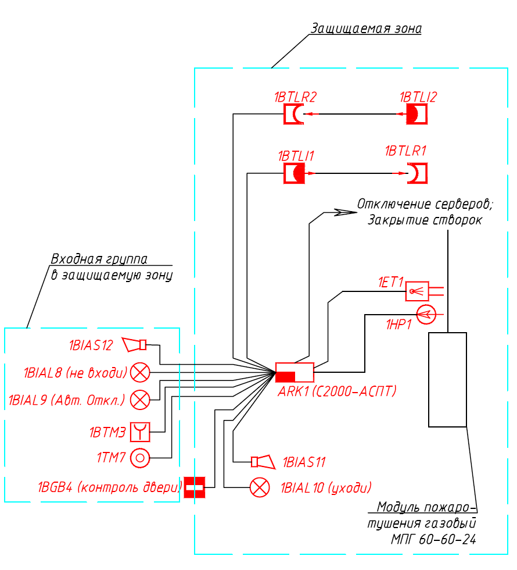
Legend
Protected zone
Item No. | Description | Plan Designation | Item Identification
 | S2000-M Input Control Unit
 | S2000-PT Display Panel
 | S2000-ASPT Input Control & Automatic Fire Suppression Unit
 | S2000-KPB Monitoring & Starter Unit |  | Shutdown of servers,  Closing of ventilation doors
 | RIP-24 RS Redundant Power Supply
 | PChO-2 Ignition Cylinder |  | Input group
 | Multi-Purpose Pressure Indicator Unit |  | to the protected zone
 | Point Smoke Detector
 | Remote Control Element |  | 1BIAL8 (KEEP OUT)
 | Sound Alarm (Siren)
 | Light Alarm (Light Panel) |  | 1BIAL9 (Auto Shutdown)
 | Magnetic Contact Detector
 | TouchMemory Reader
 | Route in the Cable Duct |  | (Door Status Monitoring)  (LEAVE AT ONCE)  Gaseous fire
 | Route in the corrugated PVC pipe |  | suppression

Legend:
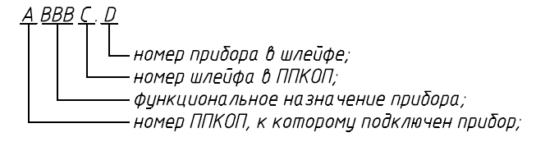
Number of FASCU, to which the device is connected;

Device functionality;
FASCU loop number;

Device loop number;

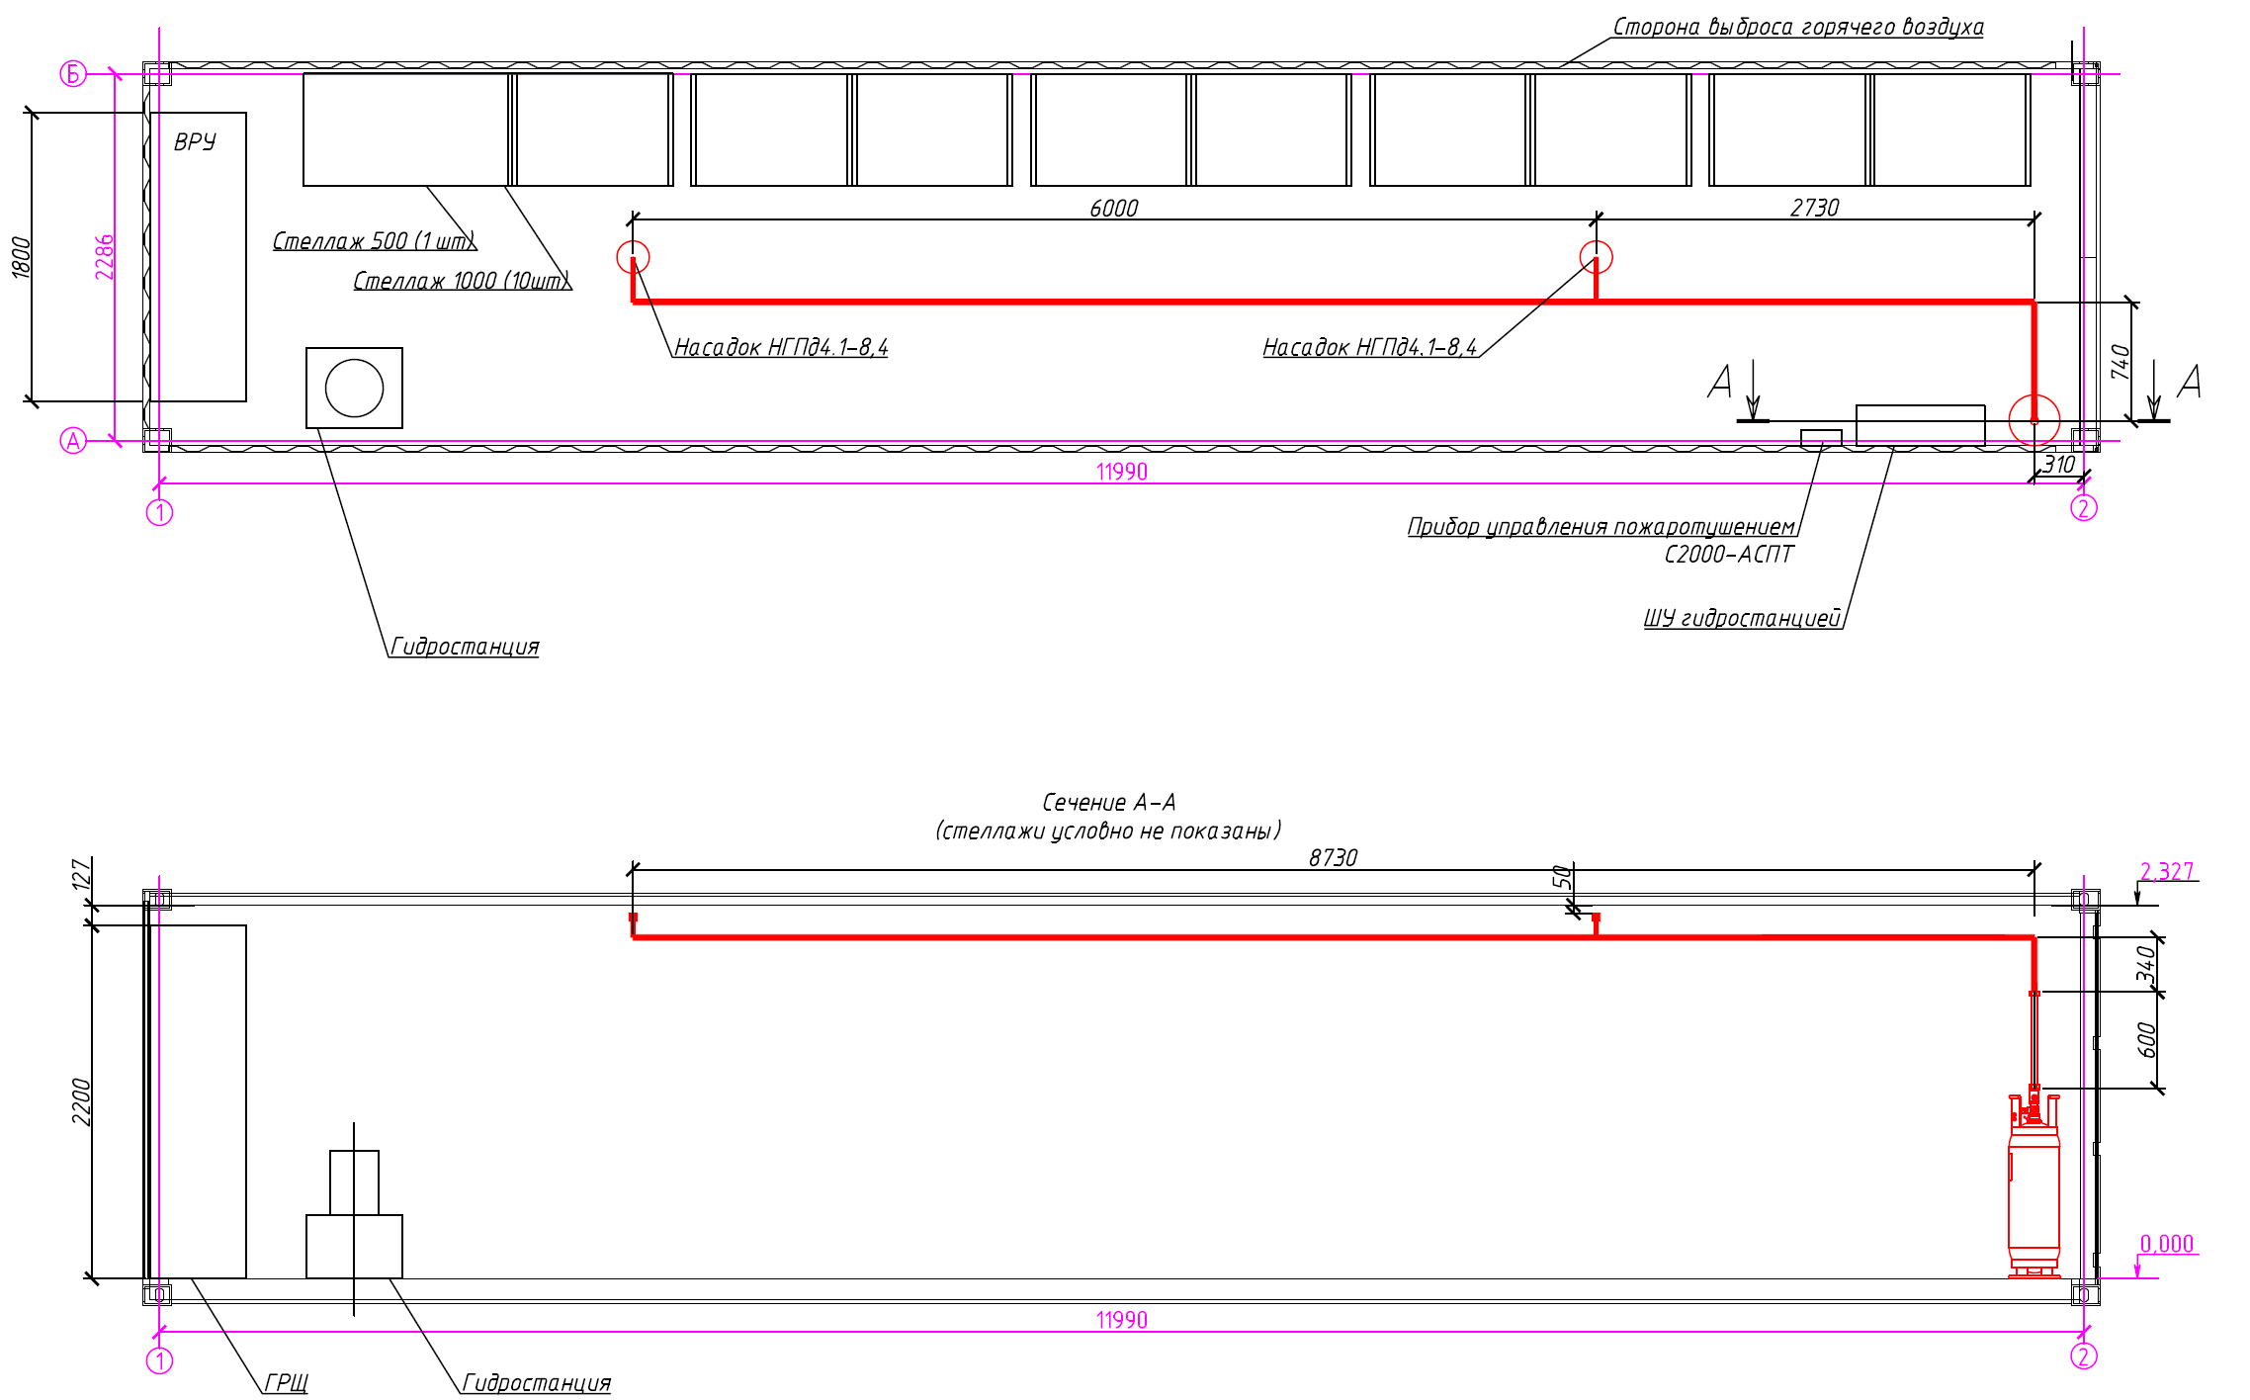
Hot air discharge side
Container Equipment Layout
Hydraulic Power Unit
Hydraulic Power Unit
Section A-A
(racks not shown for clarity)
Fire suppression controller
Hydraulic control panel
Nozzle NGPd4.1-8.4
Nozzle NGPd4.1-8.4
Rack 1000 (10 pcs)
Rack 500 (1 pcs)

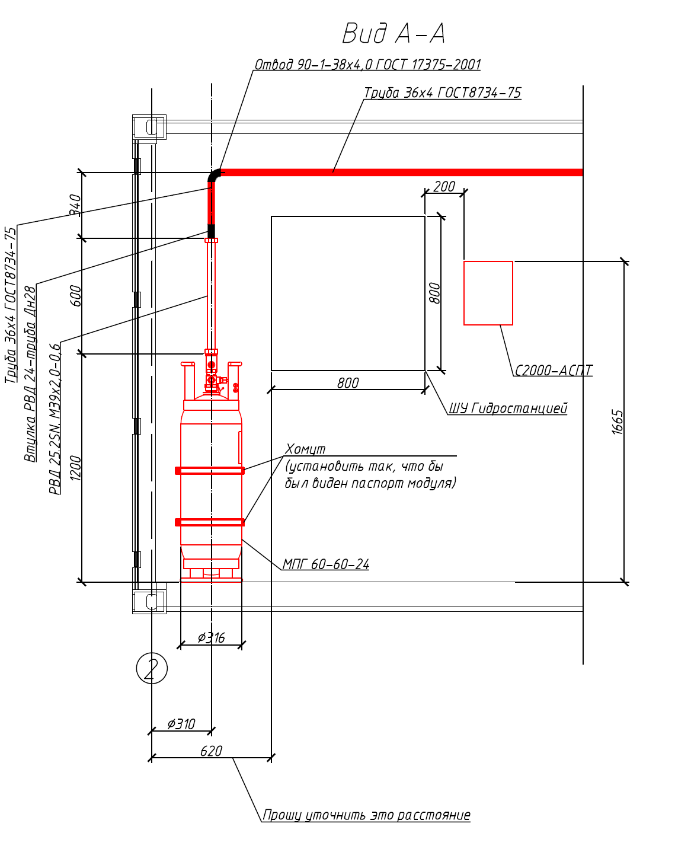
HP hose sleeve 24 - Dn28 pipe
36x4 pipe as per GOST8734-75
Distance TBD
(set so that the package nameplate can be seen)
Clamp
Hydraulic control panel
View А-А

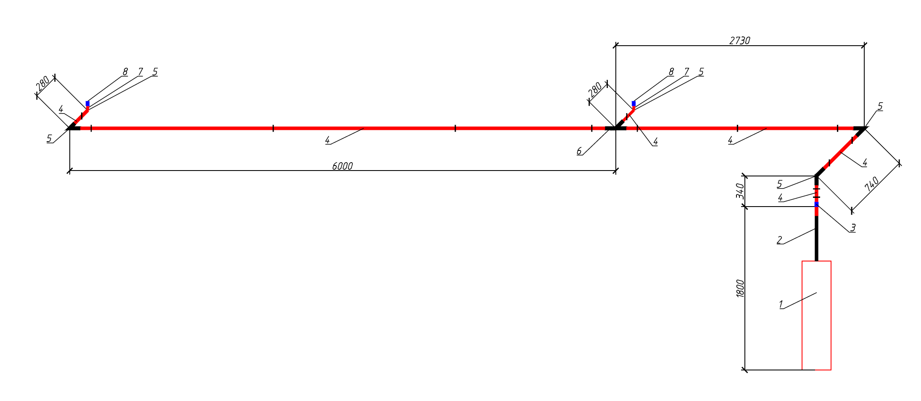
List of Equipment
Legend:
I - suspension point (Item No. 9)
Remarks
- The dimensions are shown by pipe centerlines;
- The pipeline to be mounted with a step of at least 2 m;

Item No. | Description | Designation | Unit | Qty | Remark
1 | Fire Suppression Package | MPG 60-60-24 | pcs | 1
2 | High-Pressure Hose | HP hose, 25.2SN. М39х2.0-0.6 | pcs | 1
3 | Reducing Sleeve | HP hose sleeve 24 - Dn28 pipe | pcs | 1
4 | Pipe | 36x4 GOST 8734-75 | m | 12
5 | Bend | 90-1-38x4.0 GOST 17375-2001 | pcs | 5
6 | Straight Tee | 38x4.0  GOST 17376-2001 | pcs | 1
7 | Nozzle Sleeve | 01 | pcs | 2
8 | Nozzle | NGPd4.1-8.4 | pcs | 2
9 | Pipe Clamp | MP-MI 1" G | pcs | 14

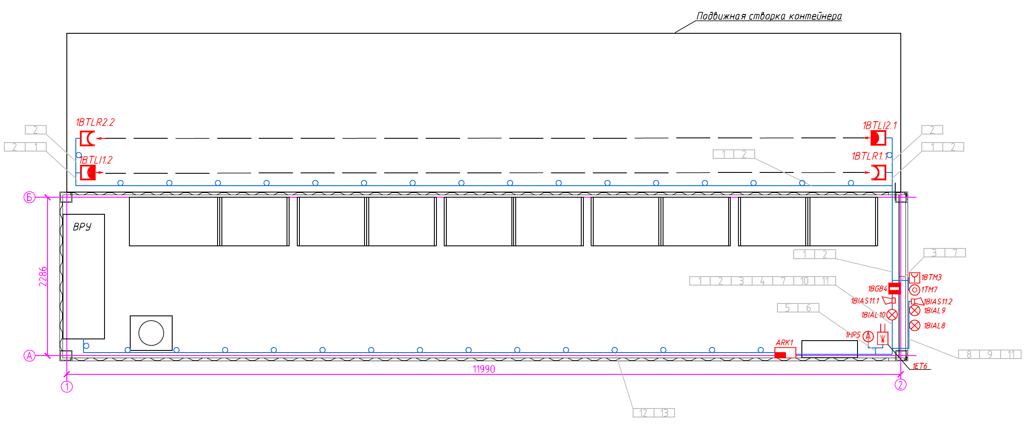
Container movable door

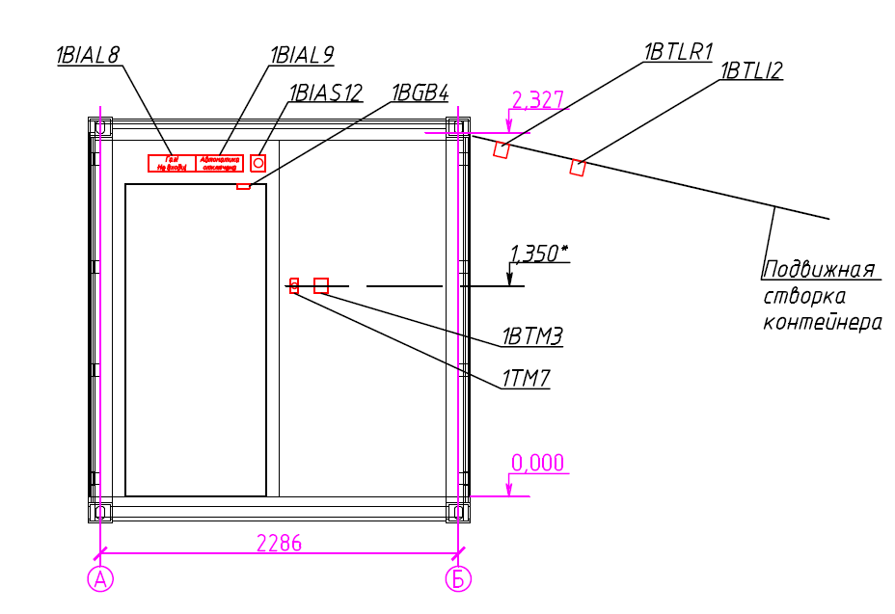
Container movable door

Container movable door

Cable / Wire Designation | Route |  | Cable / Wire Route Section | Cable / Wire
Cable / Wire Designation | Starting Point | End Point | Cable / Wire Route Section | Designed |  |  | Laid
 |  |  |  | Brand | Core Number & Section | Length,  m | Brand | Core Number & Section | Length,  m
1 | ARK1 | 1BTLR1.1 - 1BTLI1.2 | In the corrugated PVC tube d16 | KShSGng(A)-FRLS | 2x2x0.60 | 30
2 | ARK1 | 1BTLR2.1- 1BTLI2.2 | In the corrugated PVC tube d16 | KShSGng(A)-FRLS | 2x2x0.60 | 30
3 | ARK1 | 1ВТМЗ | In the corrugated PVC tube d16 | KShSGng(A)-FRLS | 1x2x0.60 | 12
4 | ARK1 | 1BGB4 | In the corrugated PVC tube d16 | KShSGng(A)-FRLS | 1x2x0.60 | 12
5 | ARK1 | 1НР5 | In the corrugated PVC tube d16 | KPSng(A)-FRLS | 1x2x0.5 | 10
6 | ARK1 | 1ЕМ6 | In the corrugated PVC tube d16 | KPSng(A)-FRLS | 1x2x0.5 | 10
7 | ARK1 | 1ТМ7 | In the corrugated PVC tube d16 | KShSGng(A)-FRLS | 2x2x0.60 | 12
8 | ARK1 | 1BIAL8 | In the corrugated PVC tube d16 | KShSGng(A)-FRLS | 1x2x0.60 | 10
9 | ARK1 | 1BIAL9 | In the corrugated PVC tube d16 | KShSGng(A)-FRLS | 1x2x0.60 | 10
10 | ARK1 | 1BIAL10 | In the corrugated PVC tube d16 | KShSGng(A)-FRLS | 1x2x0.60 | 10
11 | ARK1 | 1BIAS11.1 - 1BIAS11.2 | In the corrugated PVC tube d16 | KShSGng(A)-FRLS | 1x2x0.60 | 17
12 | ARK1 | MDB | In the corrugated PVC tube d16 | KPSng(A)-FRLS | 1x2x0.5 | 17
13 | MDB | Hydraulic control panel | In the corrugated PVC tube d16 | KPSng(A)-FRLS | 1x2x0.5 | 17

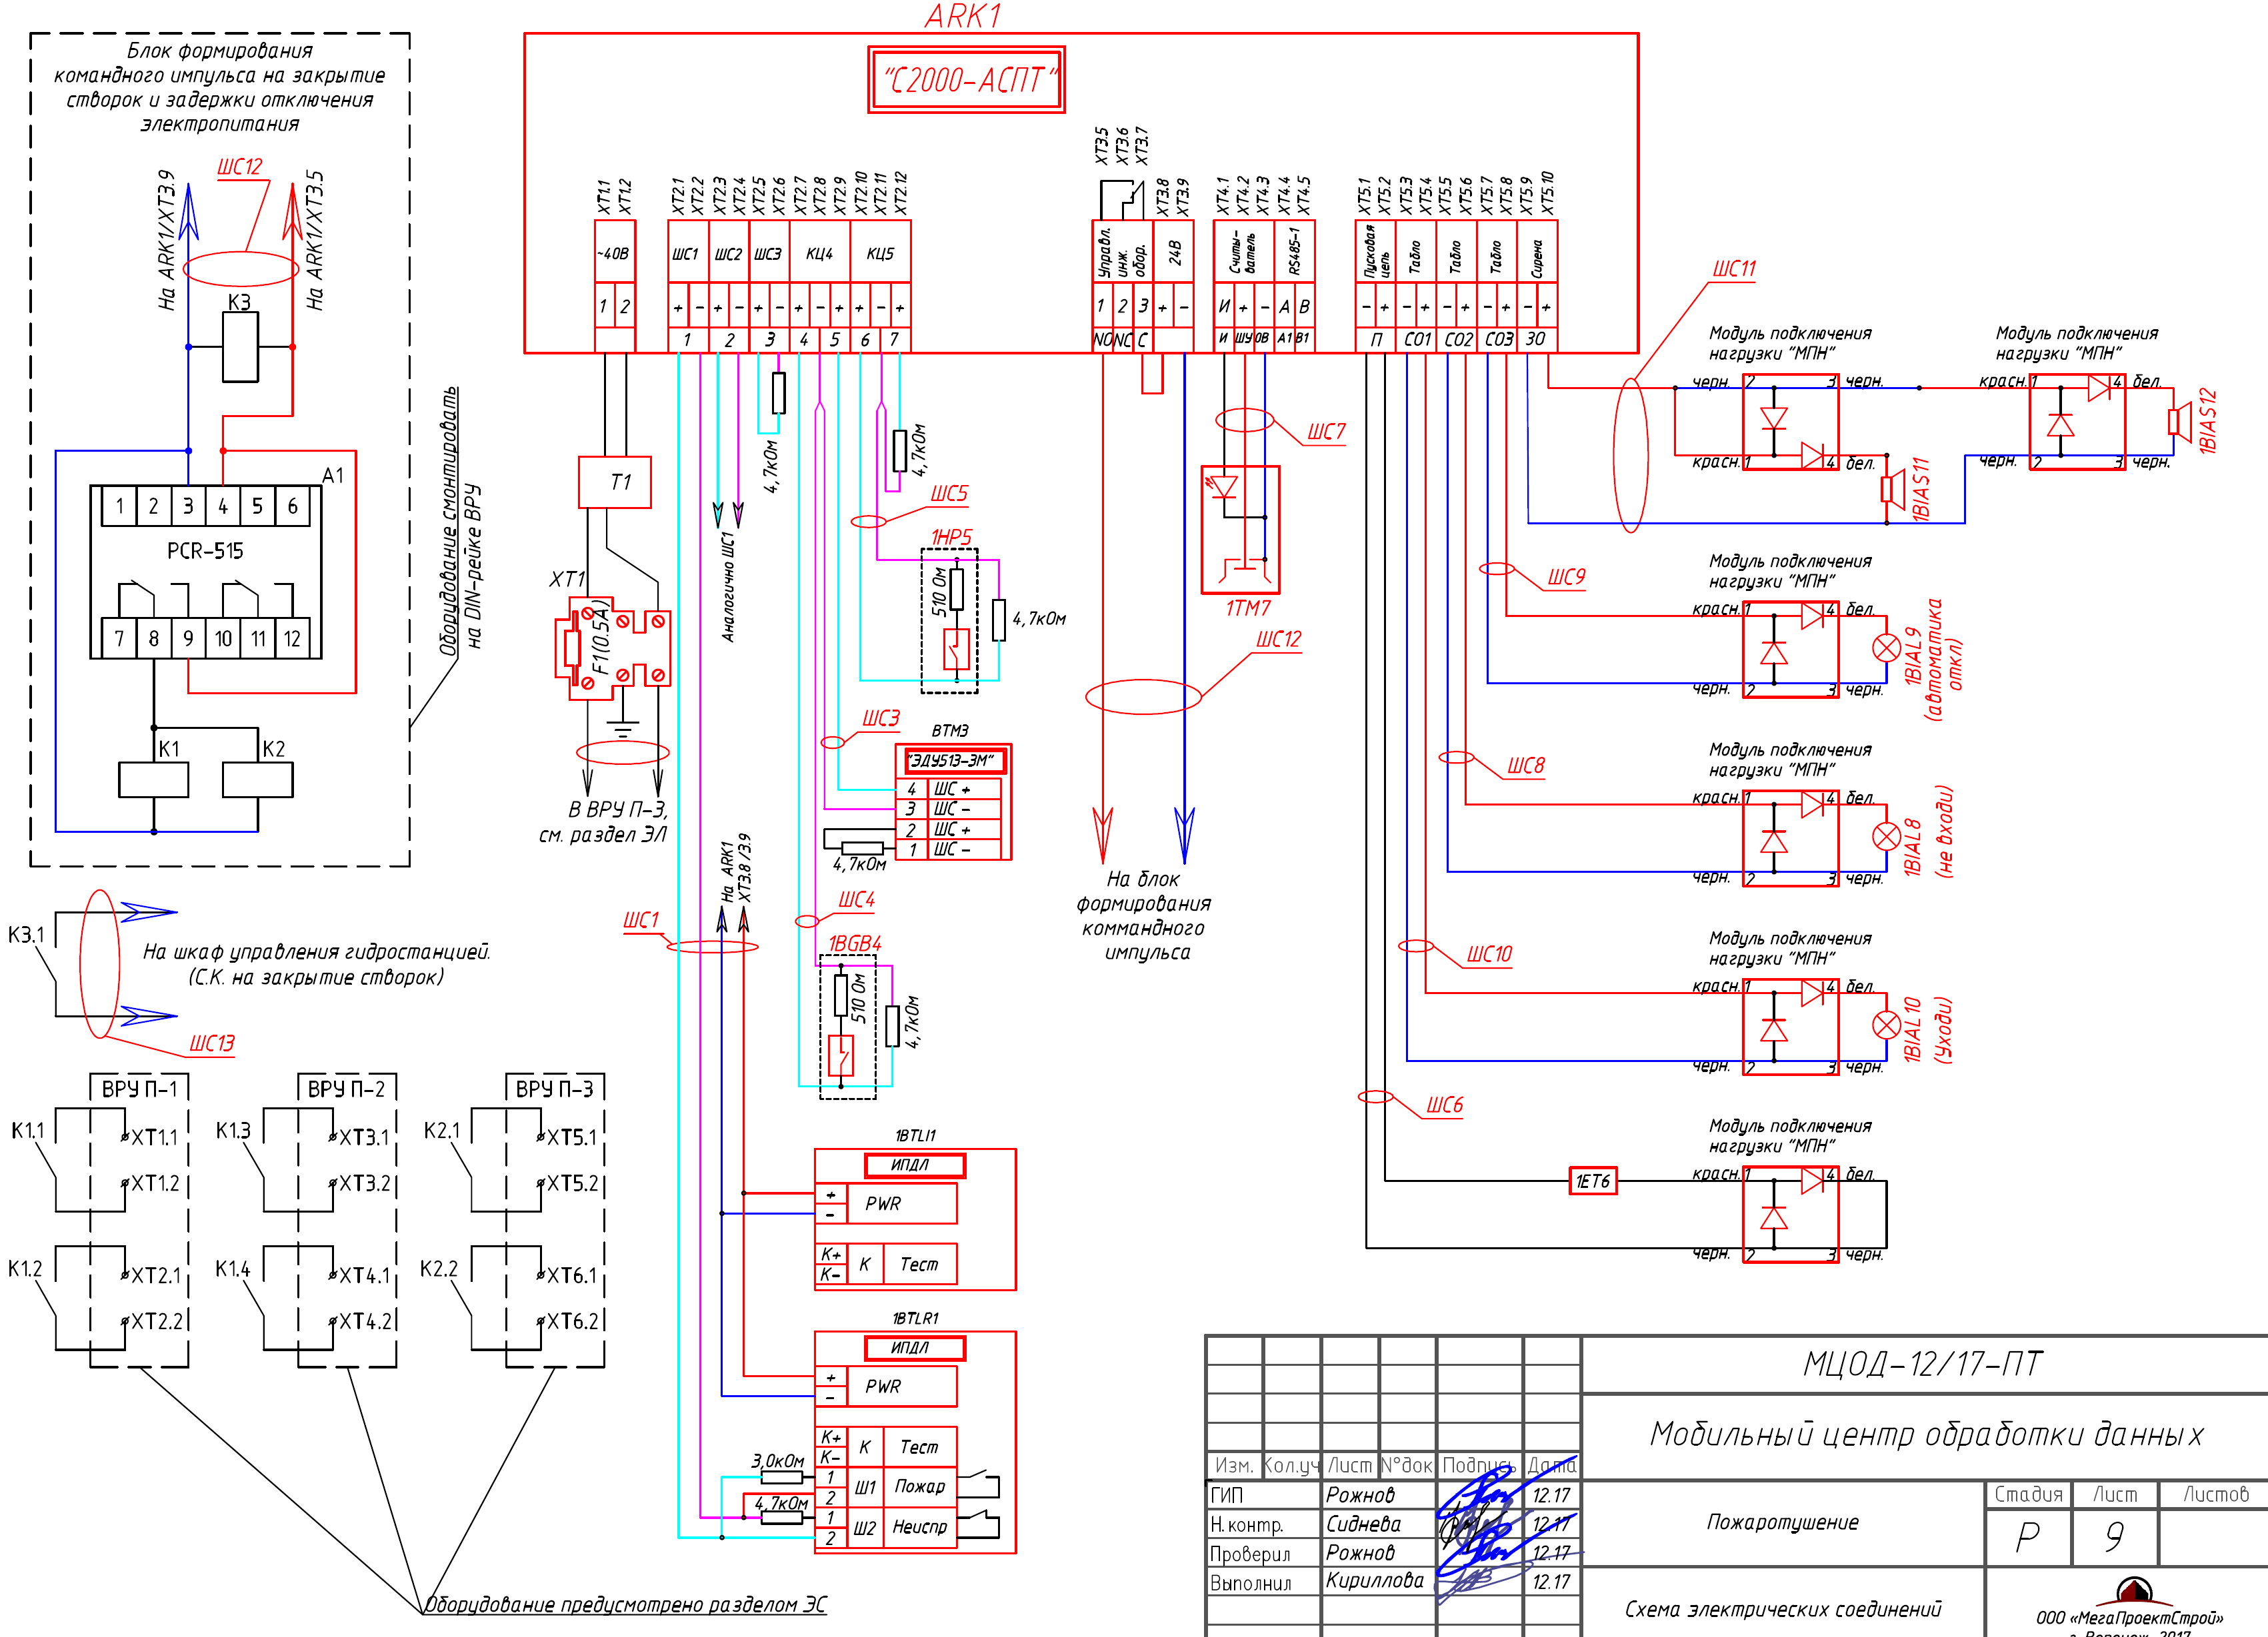
Load connection unit "LCU"
black
black
white
black
(shutdown automation)
Equivalent to AL1
In LID P-3, see Section EL
To ARK1
ХТ3.8/3.9
Reader
Eng. equip. control
Starting circuit
Siren
Light panel
Light panel
Light panel
red
(KEEP OUT)
To ARK1/ХТЗ.5
To ARK1/ХТЗ.9
(LEAVE AT ONCE)
Load connection unit "LCU"
Load connection unit "LCU"
Load connection unit "LCU"
Load connection unit "LCU"
white
black
black
black
red
red
red
red
black
black
white
white
white
black
black
red
white
black
black
Command pulse unit
Test
Fault
Fire
Test
The equipment is specified in the EPS section
To hydraulic control cabinet.
(S.K. to close doors)
Install equipment
to LID DIN rail
Command pulse unit to close doors and delay deenergization
Load connection unit "LCU"

Item No. | Name and Specification | Type, Brand, Document/Checklist Index | Equipment, Item, Material Code | Manufacturer | Unit | Quantity | Unit Weight, kg | Remark
1 | 2 | 3 | 4 | 5 | 6 | 7 | 8 | 9
 | Process equipment
1 | Package 60 bar, 60 liters, DN 24mm, H = 860mm, d = 311mm, m = 31 kg, | MPG60-60-24 |  | NPO PAS | pcs | 1
2 | Gas fire extinguishing agent compound | HFC-125 |  | NPO PAS | kg | 49
3 | Starting device | PChO-2 |  | NPO PAS | pcs | 1
4 | Multi-Purpose Pressure Indicator Unit | SDU |  | NPO PAS | pcs | 1
5 | High-pressure hose Dn25, М39х2, L=600mm | HP hose, 25.2SN. М39х2.0-0.6 |  | NPO PAS | pcs | 1
6 | HP hose reducer D (outer) 28 | HP hose sleeve 24 - Dn28 pipe |  | NPO PAS | pcs | 1
7 | Rigid clamp | KhZh316 |  | NPO PAS | pcs | 2
8 | 36x4 pipe as per GOST 8734-75 | 36x4  GOST 8734-75 |  |  | m | 12
9 | 90-1-38x4.0 bend as per GOST 17375-2001 | 90-1-38x4.0 GOST 17375-2001 |  |  | pcs | 5
 | 38x4.0 straight tee as per GOST 17376-2001 | 38x4.0 GOST 17376-2001 |  |  | pcs | 1
10 | Threaded nozzle welded sleeve G1 | 01 |  | NPO PAS | pcs | 2
11 | Threaded nozzle 01 | NGPd4.1-8.4 |  | NPO PAS | pcs | 2
12 | Heavy duty pipe clamp | MP-MI 1" G | 20847 | Hilti | pcs | 14
13 | Pin М12, L=1000mm | SM201201 |  | DKC | pcs | 7
 | Spare parts & accessories
14 | Package 60 bar, 60 liters, DN 24mm, H = 860mm, d = 311mm, m = 31 kg, | MPG60-60-24 |  | NPO PAS | pcs | 1
15 | Gas fire extinguishing agent compound | HFC-125 |  | NPO PAS | kg | 49
16 | Starting device | PUO-2 |  | NPO PAS | pcs | 1
17 | Test cup 01 |  |  | NPO PAS | pcs | 2
 | Automatic fire fighting equipment
18 | Fire suppression controller | S2000-ASPT |  | Bolid | pcs | 1
19 | Battery 12V / 4.5Ah | DT12045 |  | Delta | pcs | 2
20 | Two-component line type detector | IPDL-D-I/4R |  | Poliservis | pcs | 2
21 | Remote Control Element | EDU-513 |  | Bolid | pcs | 1
22 | Magnetic contact detector | IO-102-20 B2P |  | KSS | pcs | 1

Item No. | Name and Specification | Type, Brand, Document/Checklist Index | Equipment, Item, Material Code | Manufacturer | Unit | Quantity | Unit Weight, kg | Remark
1 | 2 | 3 | 4 | 5 | 6 | 7 | 8 | 9
23 | Sounder beacon | Mayak-24-KP |  | Electrical Equipment & Automation | pcs | 2
24 | "GAS HAZARD! KEEP OUT!" light panel, hidden inscription | LIUKS-24-SN "GAS HAZARD! KEEP OUT!" |  | Electrical Equipment & Automation | pcs | 1
25 | "GAS HAZARD! LEAVE AT ONCE!" light panel, hidden inscription | LIUKS-24-SN "GAS HAZARD! LEAVE AT ONCE!" |  | Electrical Equipment & Automation | pcs | 1
26 | Light panel "Automation Disabled", hidden inscription | LIUKS-24-SN "Automation Disabled" |  | Electrical Equipment & Automation | pcs | 1
27 | Touch Memory reader | Reader-1 |  | Bolid | pcs | 1
28 | Touch Memory key |  |  | Dallas | pcs | 6
29 | Electromagnetic relay, 4 groups, 24V | RXM4AB1BD |  | Schneider Electric | pcs | 3
30 | Terminal block | RXZE2M114 |  | Schneider Electric | pcs | 3
31 | RXZ4 clamp for RXM4 relay | RXZ400 |  | Schneider Electric | pcs | 3
32 | Time relay, 220V, cont.2R, on delay, DIN mounting | PCR-515 | ЕА02.001.006 | F&F | pcs | 1
 | Materials
33 | Fire alarm cable | KPSng(A)-FRLS 1x2x0.5 |  | Spetskabel | m | 60
34 | Fire alarm cable | KShSGng(A)-FRLS 1x2x0.60 |  | Spetskabel | m | 80
35 | Fire alarm cable | KShSGng(A)-FRLS 2x2x0.60 |  | Spetskabel | m | 80
36 | Corrugated PVC pipe D16 | 91916 |  | DKC | m | 220
37 | Pipe clip D16 | 51016 |  | DKC | pcs | 440
38 | Solid tray 100x50x3000 | 35022 |  | DKC | m | 3
39 | Tray cover, base 100 | 35522 |  | DKC | m | 3

  - General Information 2
  - Main Detailed Design Decisions 2
  - Electric Power Supply of Units 4
  - Equipment Layout 5
  - Cable Communication Lines 5
  - Requirements for Installation and Operation 6
  - Occupational Safety Requirements 6
  - Installation of Equipment and Wiring 8

- General Information

The detailed design documentation has been executed in accordance with the requirements:
- Federal Law of the Russian Federation No. 123-FZ "Technical Regulations on Fire Safety Requirements" of July 22, 2008, as amended as of July 10, 2012; July 2, 2013; June 23, 2014;
- SP 3.13103.2009 "Public Address/General Alarm System. Requirements of Fire Safety";
- SP 5.13130.2009 "Automatic Fire-Extinguishing and Alarm Systems. Designing and Regulations Rules";
- SP 6.13130.2013 "Systems of Fire Protection. Electrical Equipment. Requirements of Fire Safety";
- GOST R 21.1101-2013 "System of Design Documents for Construction. Main Requirements for Design and Working Documents";
- GOST 31565-2012 "Cable Products. Requirements of Fire Safety";
- RD 78.145-93 MIA of Russia "Guidelines. Security Alarm, Fire Alarm, and Security Fire Alarm Systems and Assemblies. Installation and Acceptance Requirements";
- EIC (7th ed.). Electrical Installations Code.

The detailed design documentation is allowed for the performance of works after it has been checked and agreed with the Customer.
The detailed design documentation has been developed in accordance with the requirements of environmental, sanitary and hygiene, fire safety and other rules and regulations in force in the Russian Federation.

2. Main Detailed Design Decisions

In accordance with the regulatory documents, the detailed design provides for a gaseous fire system (hereinafter referred to as GFS). The detailed design also provides for the public address/general alarm system (hereinafter referred to as PA/GA).
The fire alarm technical facilities include:
- The S2000-ASPT input control and automatic fire suppression unit;
- Touch Memory reader (Reader-2);
- Touch Memory electronic key with an SB 1990 A holder;
- EDU 513-3М remote control electrical contact device;
- IPDL-D-ii/4r line type electronic smoke detector;
- LIUKS-24 SN "GAS HAZARD! LEAVE AT ONCE!" fire alarm device;
- LIUKS-24 SN "GAS HAZARD! KEEP OUT!" fire alarm device;
- LIUKS-24 "Automation Disabled" fire alarm device;
- Mayak-24-KP sounder beacon;
- IO 102-20 B2P magnetic contact point smoke detector;
- Delta DTM 12045 12V/4.5 Ah sealed lead-acid battery;
- Cable & wire networks.
The design decisions provide for the gaseous fire suppression in the container for server equipment.
The S2000-ASPT input control and automatic fire suppression unit is designed for operation as part of an automatic gaseous fire suppression. The fire suppression has both an automatic control using signals from fire alarm devices and a remote control using an electrical contact device.

The IPDL-D-ii/4r line type electronic smoke detectors are provided to detect fire in the premises to increase the optical density of the environment when it is smoked. The remote start of the fire suppression system is carried out using the EDU 513-3М remote control electrical contact device.
Once the fire alarm signal has been received from the detectors in the automatic mode, the alarm system will be activated and an on delay enabled before the fire suppression system is started. The on delay feature is necessary to evacuate personnel from the container and close the ventilation doors. As soon as the time required for closing of the ventilation doors has elapsed, the LID incoming circuit breakers will be disabled merely to deactivate the built-in fans. After that, a command pulse will be output to the package's ignition cylinder, followed by release of the gas fire extinguishing agent compound into the container.
In case of fire, the security detector sends a door status (open/closed) monitoring signal to the S2000-ASPT unit to automatically block the GFES release if there are people in the container.
In accordance with SP 3.13103.2009, premises with electrical equipment shall be equipped with an automatic warning and evacuation control system for category I fire.
The detailed design provides for the following sound and light alarm aids:
- LIUKS-24 SN "GAS HAZARD! LEAVE AT ONCE!" fire alarm device;
- LIUKS-24 SN "GAS HAZARD! KEEP OUT!" fire alarm device;
- LIUKS-24 "Automation Disabled" fire alarm device;
- Mayak-24-KP sounder beacon.
The alarm system starts automatically when two detectors (hereinafter referred to as the detectors) are triggered. In the event of a fault of any detector, a "faulty" message will be output to the S2000-ASPT control unit.

3. Electric Power Supply of Units

Automatic fire alarm electrical circuits shall be executed in accordance with EIC (7th edition). In terms of ensuring the electric reliability, the automatic fire alarm system is assigned to category I consumers in accordance with EIC.

In terms of protecting personnel from electrocution, automatic fire alarm systems have items of electrical equipment complying with the requirements of GOST 12.2.007.0-75.
Protective grounding of automatic fire alarm electrical equipment to be executed in accordance with the requirements of EIC and the manufacturer's technical documentation.
The S2000-ASPT unit shall have its working (main) power supply carried out from the 220 VAC 50 Hz:
The backup power supply shall be carried out from the batteries built in the S2000-ASPT.
The transfer of power supply from the main to the backup and vice versa shall be carried out automatically.
The connection of the 220V network to the devices, the connection of the equipment housings to the grounding circuit shall be carried out on site during installation. The grounding shall be executed as per SNiP 3.05.06-85 and EIC.
- Equipment Layout
To automatically detect the fire of equipment, the detailed design provides for the installation of the automatic smoke detectors under the ventilation door.
The remote manual start-up is provided by the EDU 513-3М remote control electrical contact device installed at the inlet to the container at a height of 1.5 m from the ground level.
For the timely notification of personnel about a fire in the premises, the detailed design provides for Class 1 Public Address/General Alarm System. The sound and light alarm notification method is used.
The LIUKS-24 SN "GAS HAZARD! LEAVE AT ONCE!", LIUKS-24 SN "GAS HAZARD! KEEP OUT!", and LIUKS-24 "Automation Disabled" fire alarm devices to be installed above the door to the container. The Mayak-24-KP sounder beacon shall be installed above the entrance door both inside and outside the container.
- Cable Communication Lines
The choice of wires and cables, as well as their laying methods have been provided in accordance with EIC and RD 78.145-93.
Cables shall be laid (in compliance with the requirements of SP 5.13130.2009) in the corrugated PVC pipe.
The following communication lines shall be provided (subject to the requirements of GOST 315652012):
- Stationary control lines (with no operational bends) using a KPSng(A)-FRLS 1x2x0.5 cable.
- Stationary lines with occasional bends when opening/closing the doors/doors of the container using KShSGng(A)-FRLS 1x2x0.60 and KShSGng(A)-FRLS 2x2x0.60 cables.

Cable routes and cable laying methods can be changed on site subject to the current norms and standards.
All fire alarm electrical wiring uses a flame-resistant cable.
The distance between the fire alarm cables and power cables must be at least 0.25 m.
Prior to laying cables and wires, they must be subjected to visual inspection. In addition to the visual inspection, electrical cable resistance must be measured and the integrity of conductor insulation checked.
Cable connections shall be executed in accordance with the cable network layout. The cable laying and installation work must be carried out in compliance with the safety regulations.
  - Requirements for Installation and Operation

The GFS and PA/GA systems developed on the basis of the detailed design documentation shall be operated on a continuous basis.
The unit installation and operation must be carried out in compliance with the requirements specified in the technical documentation of the equipment manufacturers. The installation work must be performed by a specialized organization certified by the MES of Russia in accordance with the technical documentation for the devices, as well as in accordance with the requirements of the fire safety regulatory documents.
  - Occupational Safety Requirements

Installation work must be carried out by a specialized organization in the construction preparedness and in strict compliance with applicable standards.
Persons having at least an electrical safety group III can be admitted to work.
Installation and assembly work shall be commenced following the implementation of the HSE measures as per SNiP 12-04-2002 and the execution of the acceptance control certificate.
The operation of electric power tools requires compliance with the requirements of GOST 12.2.013.0-91.
Fire suppression equipment is safe for operating and maintenance personnel who observe the operation and maintenance rules and regulations, and causes no harm to health of persons near it. Personnel operating the FS and PG/GA equipment must undergo the safety training and observe safety precautions.
All electrical installation work, equipment maintenance, protective equipment inspection intervals and methods shall comply with the "Regulations for Operation of Consumer Electrical Installations".
The maintenance personnel must have practical skills in operating equipment and be aware of the safety precautions for operating electrical installations of up to 1000V.
The requirements of SNiP 3.05.06-85 and EIC must also be met when performing electrical installation work.
Electrical installations may be operated and maintained by persons who have passed preliminary and periodic medical examination, have permits to work with electrical installations and a certificate of verification of knowledge, norms and rules of working with electrical installations (at least electrical safety group III); as well as those who have passed the introductory HSE briefing and the tool box talk on safe working methods.
Mounting and repair work in electrical networks and devices (or in vicinity thereof), as well as wiring work must be carried out with the voltage removed. In this case, it is necessary to carry out inspection for the absence of voltage, provide the grounding, and install the prohibiting/warning signs. However, a permit to work shall be issued when performing work at height, in confined and hard-to-reach spaces, as well as in existing electrical installations. Construction electricians (wiremen) responsible for the maintenance of electrical installations must wear overalls, safety footwear and personal protective equipment (PPE) at all times, and should also be provided with electrical safety devices that are subject to periodic inspection. All electrical installation work, maintenance of electrical installations, inspection intervals and methods of electrical safety devices shall comply with the Gosenergonadzor's "Regulations for Operation of Consumer Electrical Installations".
8. Installation of Equipment and Wiring

Before starting any work, the assembly organization shall familiarize itself with the detailed design and review the equipment used.
Equipment may be installed following the acceptance control with the drawing up of the acceptance control certificate as required.
Equipment should be installed in accordance with the established procedure:
- Check pipes for the cable/wire pass through;
- Fix trays and PVC pipes in the indicated places;
- Install wires;
- Install equipment;
- Connect actuators to their respective controllers;
- Verify proper function and operation of individual devices and the entire system.
Installation and maintenance of the system may be carried out by persons who have been briefed in safety precautions. Briefing shall be logged.
Installation work require compliance with the requirements of SNiP 12-04-2002. Occupational Safety in Construction. Part 2. Construction Operations", Sections 8 to 18, EIC.
When performing construction and assembly works, the workplaces of installers must be equipped with safety devices.
Persons having at least an electrical safety group III can be admitted to work.
When working with electrical installations, warning signs must be installed. For existing electrical installations, electrical installation work shall be performed only with the voltage removed.
Wiring work should be performed in accordance with the detailed design (inspection report and standard design decisions) subject to the requirements of EIC and SNiP 3.05.06-85.
For parallel exposed laying of wires/cables of communication, power and lighting lines, the distance between them should be at least 0.5 m, otherwise induced-noise protection should be provided.
Cable routes should be designed as short as possible given the location of electric lighting networks, as well as other utilities. Wires and cables to be laid along the walls inside the container should be laid at least 0.1 m from the ceiling, and typically at a height. Wires and cables to be laid at an elevation of at least 2.0 m from the ground level must be protected against mechanical damage.
Wiring that passes along the outer walls at an elevation of less than 2.5 m from the ground level or through the premises that are not subject to protection must be laid hidden way or in metal pipes.
When crossing power supply and lighting networks, cables and wires must be protected with rubber or PVC pipes, the ends of which should protrude by 4-5 mm from each side of the passage. In this case, cables with a larger capacity must be adjacent to the wall, with that with a smaller capacity bending them from above.
When laying cables at the turn points at an angle of 90 degrees (or close to it), the bend radius must be at least seven cable diameters.
Cables and wires should be fastened to building structures using clamps or clips of thin sheet galvanized steel, as well as elastic polyethylene clamps. Fasteners should be installed using screws or adhesive.
When laying multiple cables/wires in a single route, they can be bunched.
It is recommended to use distribution and junction boxes for connecting and branching wires and busbars.

Facility: Mobile Data Processing Center

Hydraulic Calculation of Packaged Automatic Gaseous Fire Suppression
Facility: Equipment Container

The hydraulic calculation has been executed on the basis of the methodology and using the "Gamma-Potok" software developed by the NPO "Pozharnaya Avtomatika Servis"

12/26/2017
12/26/2017
Q/RF-OawuG-eIkpg-nUN9p-+xIj

Page 1 of 4

Calculation dated:
Code for manufacturer

Hydraulic Calculation: Equipment Container
Basis of Design
Unit type |  | Packaged
Package type |  | MPG 60-60-24
Number of packages | pcs | 1
Equivalent package length | m | 8.1
GFES type |  | HFC-125
Package pressure at 20°С | bar | 37
Fire suppression module operating efficiency Keff | kg/l | 0.82
Minimum mass of GFES for creating fire-extinguishing concentration in the protected premises (MP) | kg | 45.55
Total amount of GFES loaded into packages | kg | 49
Standard delivery time of GFES | s | 10
Nozzle minimum inlet pressure | bar | 10.81
Data on Pipeline Sections
Section |  |  | Length, m | Inner Diameter, mm | Elevation, m | Item at the Section End | Section Nozzles | Name of Section
Item No. | Starting Point | End Point
1 | 1 | 2 | 0.34 | 28 | 0.34 | Bend |  | Main line
2 | 2 | 3 | 0.74 | 28 | 0 | Bend |  | Main line
3 | 3 | 4 | 2.73 | 28 | 0 | Tee |  | Main line
4 | 4 | 5 | 6 | 28 | 0 | Bend
5 | 5 | 6 | 0.28 | 28 | 0 | Bend
6 | 6 | 7 | 0.05 | 28 | 0.05 | Nozzle | T1-01
7 | 4 | 8 | 0.28 | 28 | 0 | Bend
8 | 8 | 9 | 0.05 | 28 | 0.05 | Nozzle | T1-02
Calculation Data
Unit type |  | Packaged
Estimated delivery time of GFES | s | 9.7
Total volume of the pipeline | m³ | 0.0064
Ratio of the pipeline internal volume to the GFES liquid phase volume | % | 15.79
GFES residue in the pipeline | kg | 0.0336
The residue in the pipeline to be neglected due to its littleness (if 1% of M_{est})
Distributor used | kg | 45.55
Protected premises
Page 2 of 4
Name of the Protected Zone | М_{est}, kg |  | Nozzle
Name of the Protected Zone | Required | Supplied | Calculation Designation | Type
Container | 45.55 | 45.49 | T1-** | NGPd 4.1-8.4
Total | 45.55 | 45.49
Data on Nozzles
Nozzle | Reduced Nozzle Diameter, mm | Qty of Holes, pcs | Hole Size, mm | Nozzle Inlet Pressure, bar | Nozzle Flow Rate, kg/s | GFES Feed Time, s | Nozzle Flow Differential, %
Т1-01 | 16.8 | 4 | 8.4 | 16.1 | 2.23 | 9.7 | 9.81
Т1-02 | 16.8 | 4 | 8.4 | 16.94 | 2.46 | 9.7 | 9.81

Data on Pipes
Internal Pipe Size, mm | Estimated Length, m | Recommended Pipe Type
28 | 10.47 | 36х4.0
Data on Bends
Internal Bend Diameter, mm | Number of Bends | Recommended Bend Type
28 | 5 | 90--36х4.0
Data on Tees
Internal Tee Diameter, mm | Number of Tees | Recommended Type
28 | 1 | -36х4.0

Pipeline Axonometric View

Page 3 of 4
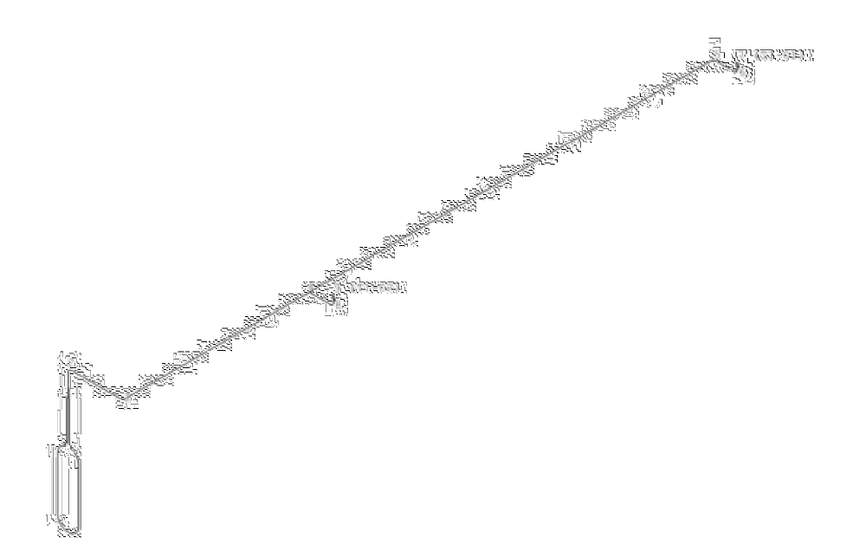

Page 4 of 4

