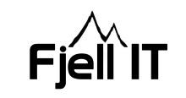
Date 24.03.2018

Have gotten one more offer from CCTV/alarm company and its uploaded.

Asked several suppliers for an offer on fire/burglary insurance. Have gotten and uploaded one offer so far.

There`s been some misunderstanding in the project regarding responsibilities and prices. All parties in the project have some degree om fault. The misunderstanding is fixed and Norconsult will have the responsibility following up the sub-contractors and their prices (NØES and Tronfjell Maskin).

Productive meeting with NØES and Tronfjell Maskin.
After meetings with NØK and Alvdal Kommue, they look like being on schedule.

Fjell IT have some questions regarding technical solutions for the containers and office building.
Denis will provide answers.

My time away have been delayed, will inform you as soon as I have an exact date.

Sent an update to Norconsult requesting updated costs and time schedule.

