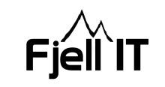
Date 10.08.2018

Monday:
- Work with cable pits and cable trenches

Tuesday:
- Worked with cable trenches/pits, Tronfjell Maskin, shipping and other
Wednesday:
- Cable pits and trenches, had a meeting with Østa Elektro.
- Arranging a meeting on Tuesday in next week, with: Østa Elektro, Tronfjell Maskin, Fjell IT and Norconsult. Topic of this meeting will be how we can be as prepared as we can, for the containers that are arriving soon.

Thursday:
- Received offer from Østa Elektro regarding cable pits/trenches and connection of 12 containers.
- Work with storage for the boxes are stopped.

Friday:
- Talked with Østa Elektro and asked them to split the offer into two phases.

