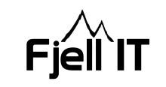
Date 20.08.2018

Monday:
- Working with Relisec and UCO regarding contract and payment
Tuesday:
- Meeting with Østa Elektro, Tronfjell Maskin and Norconsult. Topic of the meeting are how we can be done with the basics for the first containers before they arrive.
During this meeting I got the message that the first container would arrive on Wednesday
- Used time at the plot with Norconsult and TM, trying to get the top gravel ready for the first container
- See if it`s possible to get a Russian – Norwegian translator
Wednesday:
- Received the first container
- The container dug into the top gravel, not possible to get it level with top gravel alone. Worked on other solutions
- Correspondence and planning regarding CCTV and office building

Thursday:
- Received two more containers
- Correspondence with different contractors

Friday:
- Correspondence with different contractors
Sunday:
- Uploaded new photos and video of the progress on the plot.

